

Reference Model
and
Use Cases

Part 2 of 2

Developed by:
Enterprise Grid Alliance
Reference Model Working Group

*** Version 1.5 ***
As Approved by EGA
10 March 2006

This Page Intentionally Blank

Copyright Notice
Copyright ©2006 Enterprise Grid Alliance. All rights reserved. The information contained in this document may not be published, broadcast, rewritten or redistributed without the prior written authorization of Enterprise Grid Alliance. All inquiries regarding obtaining a license to this document should be directed to the EGA Executive Director at EGA_Executive_Director@mail.gridalliance.org.

Author Information

Contributor | Organization
Mukund Buddhikot | Sun Microsystems, Inc.
Alan Clark | Novell, Inc.
Michael Enescu
Brajesh Goyal | Network Appliance, Inc.
Julian Hammersley | Advanced Micro Devices, Inc.
Masato Kataoka | NEC Solutions (America), Inc.
Raj Kumar | Hewlett-Packard Company
David Pearson | Oracle Corporation
Parviz Peiravi | Intel Corporation
Stephen Schleimer | Cisco Systems, Inc.
Michael B Schmitz | Oracle Corporation
Harald Skardal | Network Appliance, Inc.
Paul Strong
Kazunori Sudo | NEC
Bob Thome--editor | Oracle Corporation
Vinod Viswanathan | Optena Corporation

Revision History
Version | Date | Comments
1.5 | 10 March 2006 | Created separate document for extensive set of new use cases.

Contents
Copyright Notice i
Author Information ii
Revision History iii
Contents iv
Figures vii
Preface viii
References x
1 Provisioning Remotely Controllable Power Supplies 1
1.1 Provision Remotely Controllable Power Supply 1
1.2 Decommission Remotely Controllable Power Supply 3
2 Provisioning Physical Compute Devices (Servers) 5
2.1 Discover Physical Compute Device (Server) 5
2.2 Configure Physical Compute Device (Server) 10
2.3 Start (Power-On) Physical Compute Device (Server) 13
2.4 Provision Physical Compute Device (Server) 15
2.5 Stop Physical Compute Device (Server) 17
2.6 Unconfigure Physical Compute Device (Server) 19
2.7 Destroy Physical Compute Device (Server) 22
2.8 Decommission Physical Compute Device (Server) 24
3 Provisioning Media 26
3.1 Provision Generic Media 26
3.2 Decommission Media 28
4 Provisioning Firmware 30
4.1 Provision Firmware 30
4.2 Decommission Firmware 33
5 Provisioning Service Processors And System Controllers 35
5.1 Provision System Controller 35
5.2 Decommission System Controller 37
6 Provisioning Hardware Partitions 39
6.1 Provision Hardware Partition 39
6.2 Decommission Hardware Partition 42
7 Provisioning Bootable Storage 45
7.1 Provision Boot Disk/LUN - Local Disk 45
7.2 Decommission Boot Disk/LUN – Local Disk 47
7.3 Provision Boot Disk/LUN - SAN 49
7.4 Decommission Boot Disk/LUN - SAN 52
7.5 Provision Boot Disk/LUN - NAS 54
7.6 Decommission Boot Disk/LUN - NAS 57
8 Provisioning Virtual Machine Managers 59
8.1 Provision VMM To Physical Server 59
8.2 Decommission VMM from Physical Server 63
9 Provisioning Virtual Servers 65
9.1 Provision Virtual Server 65
9.2 Decommission Virtual Server 68
10 Provisioning Operating Systems 70
10.1 Provision An OS Instance To A Server 70
10.2 Reboot OS 73
10.3 Decommission OS Instance From Server 76
11 Provisioning Patches 79
11.1 Provision Patch 79
11.2 Decommission (Roll back) Patch 82
12 Provisioning Pools Of Servers (Physical & Logical) 84
12.1 Create Pool Of Compute Devices (Servers) Object 84
12.2 Decommission Pool Of Compute Devices (Servers) Object 87
12.3 Monitor & Manage Pool Object 89
12.4 Add Physical Server To Pool Object 92
12.5 Remove Physical Server From Pool Object 94
12.6 Grant Admin Rights To Pool 96
12.7 Rescind Admin Rights From Pool 98
12.8 Set Pool Derived Policy 100
12.9 Set Pool Constraints 102
12.10 Set Pool Configuration 104
12.11 Get Pool Policy 106
12.12 Get Pool Configuration 108
12.13 Get Pool Billing & Accounting 110
12.14 Select From Pool Members 112
12.15 Provision Firmware To Pool 114
12.16 Decommission Firmware On Pool 117
12.17 Provision OS To Pool 119
12.18 Decommission OS On Pool 122
12.19 Set State Of Pooled Servers 124
12.20 Get State Of Pooled Servers 126
12.21 Provision Patch To Pool 128
12.22 Decommission Patch From Pool 130
12.23 Provision VMM To Pool 132
12.24 Decommission VMM from Pool 134
13 Provisioning Databases 136
13.1 Provision Database Data Files 136
13.2 Decommission Database Data Files 138
13.3 Provision A Database Instance 141
13.4 Decommission a Database Instance 144
13.5 Provision A Database Service 146
13.6 Decommission a Database Service 149
14 Provisioning Application Servers 151
14.1 Provision An Application Server Instance 151
14.2 Decommissioning an Application Server Instance 155
14.3 Provision An Application Service 158
14.4 Decommission an Application Service 162
14.5 Decommissioning an Application Server 164
Future Use Cases 165

Figures
Figure 1 – Provision OS Instance to Server DAG 71
Figure 2 – Reboot Server DAG 74
Figure 3 - Decommission OS Instance from Server DAG 77
Figure 4 - Provision Firmware to Pool DAG 115
Figure 5 - Provision OS to Pool DAG 120

Preface
This document is the second of two parts which together comprise the EGA Reference Model.
The first part contains the Introduction, EGA Reference Model, Generic Use Cases, Glossary of Terms and Appendix A.
This second part contains the specific Provisioning Use Cases.
Using the reference model as a foundation, the use cases in this document capture the processes and actors involved in the management of the lifecycle of various grid components. These use cases provide the basis for sharing enterprise grid requirements and context with the EGA’s partners – vendors, end users and standards bodies. The use cases are intended to show how to derive basic specific use cases around management scenarios for simple grid components and how these may then be used and extended to derive more complex scenarios and use cases.
It should be noted that the purpose of the use cases is to capture processes that have a large manual component today, so that they may be automated in future. These use cases are expected to form the basis of the work carried out by various EGA working groups.
Comments regarding content and format are welcome, and may be directed to the EGA Reference Model working group at ega_referencemodelwg@mail.gridalliance.org.
Additional Notes
- In the following use cases, when grid components are discovered, configured and started, their existence, state etc. are stored within the GME Repository. No assumptions are made about the repository within which the GME stores its data. The GME Repository, like the GME itself, is a single logical entity. It may be implemented as a single database instance, or as set of database instances within discrete components of the GME. It may be implemented as a federation of such databases.
- The GME repository is directly analogous to the ITIL Configuration Management Data Base (CMDB).
- Within the use cases, we describe actors who participate in the use cases. These actors are describe the roles found in today’s typical data centers. As the tasks described in these use cases are automated, many of these roles may change. They may either be subsumed by the GME, or may be combined into more general roles that do not need the same level of technical expertise. The table below describes the roles within the use cases:

Actor Name | Role definition
Data Center Admin | Data Center Admin is responsible for establishing, coordinating, and maintaining a set of operational activities and services to enforce SLA and polices ensuring that the technical architecture supports the users expectations and requirements
System Admin | A system administrator is responsible for the OS installations, configurations and maintenance such as startups, shutdowns, data backup and restoration, administration of accounts and users, operational monitoring, and software installation
Data Base Admin (DBA) | Database Administrator is responsible for the operation and administration of the DBMS, and the creation of physical database designs and maintenance
Network Admin | Network Administrator is responsible for design and operation of network infrastructure such as installing , configuring, maintaining and troubleshooting network device and components
Storage admin | Storage administrator is responsible in developing storage management program which includes allocating storage volumes; enabling quotas; managing capacity plans, changing LUN sizes; security, zoning, and backup
Hardware technician | Hardware Technician, is responsible for hardware installation, configuration and maintenance
Security Admin | Security Admin is responsible for the implementation and management of the security policies, rules and procedures.
Gird Management Entity ( (GME) | GME is that logical entity that manages  - The grid components.  - The relationships between various grid components.  - Their life cycles.  It is responsible for ensuring that the various grid components meet their goals, i.e. that the high level services and applications (eg ERP, BI, CRM etc.), deployed on the enterprise grid, meet their service level objectives within their operational constraints.

References
- Strong et al, “The Enterprise Grid Alliance Reference Model v1.0”, May 2005, Enterprise Grid Alliance.
- “Sun Fire™ Midrange Systems Platform Administration Manual, Firmware release 5.19.0”, Part No. 819-1271-10, July 2005, Sun Microsystems, Inc.
- “Solaris 10 Installation Guide: Basic Installations”, Part No. 817-0544-11, January 2005, Sun Microsystems, Inc.
- “Solaris 10 Installation Guide: Network-Based Installations”, Part No. 817-5504-11, January 2005, Sun Microsystems, Inc.
- “Solaris 10 Installation Guide: Custom Jumpstart and Advanced Installations”, Part No. 817-5506-11, January 2005, Sun Microsystems, Inc.

This Page Intentionally Blank

Provisioning Remotely Controllable Power Supplies

Provision Remotely Controllable Power Supply

Summary
A remotely controlled power switch is typically an intelligent switch with facilities to connect to physical grid components such as services or switches and be part of a data centre network. It will provide capabilities for such connected grid components to be switched on/off and rebooted through corporate networks or Internet connections. It will be compliant with standard facilities such as wake-on-lan.
This use case describes the process of provisioning a remotely controllable power supply in an enterprise grid environment. The remotely controllable power supply will enable the GME to remotely turn on and off power to the attached grid component (e.g., a server, switch, storage device).

Dependencies

Actor(s)/Stakeholder(s)
- Hardware Technician
- System Admin
- GME

Pre-Conditions
An IP based network is available for the remotely controllable power supply to be provisioned.

Initiation Of Use Case

A remotely controllable power supply is added to the data centre. It is provided with the required power supply and power redundancies.

Flow Of Events
(Basic, Alternative And Exceptional)

Basic Flow
Step 1: The Hardware Technician connects the unit to the network.
Step 2: The Hardware Technician powers the unit on.
Step 3: The system admin using the GME of the power supply, such as data centre management console or a user interface provided by the vendor is able to detect the IP address and show its properties.
Step 4: The Hardware Technicians attaches the grid components that needs to be managed to the unit.
Step 5: The system admin using the GME is able to register the IP addresses and MAC addresses of the grid components that are attached to the unit.
Step 6: The system admin using the GME is able to power on and power off the grid components that are attached to the unit.
Step 7: The system admin adds the power supply to the GME repository.

Alternative Flows

Exceptional Flows

Success Criteria
The system admin using the GME can remotely power on and power off the unit.

Post Conditions
The system admin using the GME can power on and off the grid component attached to the remotely controllable power supply.

Decommission Remotely Controllable Power Supply

Summary
A remotely controlled power switch is typically an intelligent switch with facilities to connect to physical grid components such as services or switches and be part of a data centre network. It will provide capabilities for such connected grid components to be switched on /off and rebooted through corporate networks or Internet connections. It will be compliant with standard facilities such as wake-on-lan.
This use case describes the process of decommissioning a remotely controllable power supply. Once deprovisioned, the GME will no longer be able to power on and off any attached grid component. Any attached grid components must be decommissioned prior to decommissioning the power supply.

Dependencies

Actor(s)/Stakeholder(s)
- Hardware Technician
- System Admin
- GME

Pre-Conditions
The grid components such as servers and switches connected to the power supply are decommissioned.

Initiation Of Use Case
The power supply decommissioning starts after the grid components connected to the power supply are decommissioned.

Flow Of Events
(Basic, Alternative And Exceptional)

Basic Flow
Step 1: The system admin updates the GME repository with the state of the power supply, the date it was decommissioned, the reason and archives all the information available about this component.
Step 2: The Hardware Technician powers the unit off.
Step 3: The Hardware Technician disconnects the unit to the network.

Alternative Flows

Exceptional Flows

Success Criteria
- The remotely controllable power supply is powered off

Post Conditions
- The remotely controllable power supply is no longer controllable via the GME, and is not providing power to any grid components.

Provisioning Physical Compute Devices (Servers)

Discover Physical Compute Device (Server)

Summary
This use case covers both the manual and automatic discovery/creation of a single server in the enterprise grid so that it is physically present, and exists within the GME repository. An operating system may or may not have already been installed on the server and the presence of a boot device for an operating system is not assumed. The actors one would expect to interact with the enterprise grid in the traditional data center are assumed, although it is indicated in the text where the GME could be substituted.

Dependencies
Use Case , Provision Remotely Controllable Power Supply

Actor(s)/Stakeholder(s)
- Hardware Technician
- System Admin
- GME

Pre-Conditions
- The GME exists.
- The GME repository exists.
- The data center has sufficient physical space for the server.

Initiation Of Use Case
A previously requested server is delivered to the data center.

Manual Discovery Flow Of Events
(Basic, Alternative And Exceptional)

Basic Flow
- The Hardware Technician places the server in the data center.
- The system admin adds a new class of server to be managed to the GME repository. This may include adding information such as –
- Manufacturer
- Model type
- Capabilities of model, which may include but is not necessarily limited to number of internal power supplies, number of I/O slots, networking ports, maximum and minimum number of processors, memory and internal discs etc.
- Other server type specific information necessary [for the GME] to manage the type of server.
- The system admin logs the addition of a new class of server in the GME event log.
- The system admin adds a new instance of the server to be managed to the GME repository. This act essentially adds the server to the asset register. This may include adding information such as –
- Physical location of server
- Serial number of server and any appropriate sub-components of the server.
- Host ID of server (if this exists).
- The system admin sets the server state to unconfigured in the GME repository.
- The system admin logs the discovery of the server in the GME repository event log.
[NOTE – The GME repository is more or less synonymous with the CMDB defined within ITIL. This is relationship is described more fully in the EGA Reference Model document[1].]

Alternative Flows
Steps 2 and 3: Steps 2 and 3 may be missed if a server of this class has previously been created/discovered.
Step 4: If the server type supports hardware partitions then this capability will be included.

Exceptional Flows
If any steps fail then they are either repeated until successful or until the server is removed from the data center.

Automatic Discovery Flow Of Events
(Basic, Alternative And Exceptional)

Basic Flow
- The Hardware Technician places the server in the data center.
- The Hardware Technician adds, removes and configures any hardware as appropriate.
- The system admin provisions one or more remotely controllable external power supplies (see section , Provision Remotely Controllable Power Supply).
- The system admin provisions one or more remotely controllable internal power supplies (see section , Provision Remotely Controllable Power Supply).
- The system admin or network admin configures the management network to enable access to the console, service processor or other management port of the server. The management network may be the same physical network as the general network fabric.
- The system admin logs the management network configuration change to the GME repository event log.
- The Hardware Technician physically connects the server to the management network. The management network may be the same physical network as the general network fabric.
- The system admin logs the connection to the GME repository event log.
- The system admin starts any components that are physically connected to the server and which it depends upon, for example externally attached devices, such as non-network or SAN attached disks or arrays. Note that these dependencies would be represented by another DAG.
- The system admin logs the starting of all depended upon devices to the GME repository event log.
- The system admin (or GME) connects to the remotely controllable external power supplies and switches them on. This could be as simple as using a GUI or as complex as having the connection via a terminal concentrator and then initiate a serial connection to the power controller and then use a command line interface to power the server up.
- The states of the external power supplies are updated in the GME repository.
- The system admin logs the connection of the external power supplies to the GME repository event log.
- The system admin (or GME) connects to the remotely controllable internal power supplies and switches them on.
- The system admin updates the state of the internal power supplies in the GME repository.
- The system admin logs the connection of the internal power supplies and their state change in the GME repository event log.
- The GME detects the presence of the new server.
- The GME adds a new class of server to be managed to the GME repository. This may include adding information such as –
- Manufacturer
- Model type
- Capabilities of model, which may include but is not necessarily limited to number of internal power supplies, number of I/O slots, networking ports, maximum and minimum number of processors, memory and internal discs etc.
- Other server type specific information necessary [for the GME] to manage the type of server.
- The GME adds a new instance of the server to be managed to the GME repository. This act essentially adds the server to the asset register. This may include adding information such as –
- Physical location of server
- Serial number of server and any appropriate sub-components of the server.
- Host ID of server (if this exists).
- The GME updates the GME repository to reflect the fully, physically configured server.
- The GME logs the discovery of the server to the GME repository event log.
- The system admin updates the GME repository to associate the remotely controllable external power supply/supplies with the server.
- The system admin updates the GME repository to associate the remotely controllable internal power supply/supplies with the server.
- The GME connects to the remotely controllable internal power supplies and switches them off.
- The GME updates the states of the internal power supplies in the GME repository.
- The GME logs the changes of state of the internal power supply to the GME repository event log.
- The GME connects to the remotely controllable external power supplies and switches them off.
- The states of the external power supplies are updated in the GME repository.
- The GME logs the turning off of external power supplies to the GME repository event log.
- The GME sets the server state to unconfigured in the GME repository.
- The GME logs the change in state to the GME repository event log.

Alternate Flows
Step 3: This step may be missed if a previously provisioned external power supply is to be used.
Steps 3, 11, 12, 13, 22, 27, 28 and 29: These steps may be missed if a remotely controlled internal power supply is to be used.
Steps 4, 14, 15, 16, 23, 24, 25 and 26: These steps may be missed if there are no remotely controllable internal power supplies or if only remotely controllable external power supplies are to be used.
Other alternate flows are possible, especially for automatic discovery, for example network fabric and storage fabric connectivity may be provided prior to powering up the server.

Exceptional Flows
If any steps fail then they are either repeated until successful or until the server is removed from the data center.

Success Criteria
The server is physically present in the data center and logically present within the GME repository.

Post Conditions
- The server is within the data center.
- The server has been added to the GME repository.
- The server state is set to unconfigured.

Configure Physical Compute Device (Server)

Summary
Configure a physical compute device, i.e. a server, so that it is logically manageable by the GME, i.e. manageable without the need for further physical manipulation by an administrator or Hardware Technician. Configuration could include, but is not necessarily limited to, setting physical switches, adding or removing hardware, or configuring the GME in advance of starting, i.e. powering up, the server.

Dependencies
The use case has dependencies on the following use cases:
Section , Provision Remotely Controllable Power Supply

Actor(s)/Stakeholder(s)
- Hardware Technician
- System admin
- Network Admin
- Storage Admin
- Security Admin
- GME

Pre-Conditions
- The server exists within the data center.
- The server is not powered up.
- The server has been added to the GME repository.
- The server has inherent remote management capability via a console/network connection
- If required, a remotely manageable external power switch/supply is available. This may not be required for some servers as they have remotely manageable internal power supplies or service processors that allow the main system components to be powered up and down.
- A network fabric exists.
- The management network exists. This may be the same (at least physically) as the network fabric.
- A storage fabric exists. This may be the same as the network fabric.

Initiation Of Use Case
A previously requested server is delivered to the data center and is to be made available as part of the enterprise grid. It has been placed in the data center and added to the GME, but has yet to be made logically manageable by the GME.

Flow Of Events
(Basic, Alternative And Exceptional)

Basic Flow
- The Hardware Technician adds, removes and configures any hardware as appropriate.
- The system admin updates the GME repository to reflect the fully, physically configured server.
- The system admin provisions one or more remotely controllable external power supplies (see section , Provision Remotely Controllable Power Supply).
- The system admin updates the GME repository to associate the remotely controllable external power supply/supplies with the server.
- The Hardware Technician physically connects the server to the designated external power supply/supplies.
- The system admin provisions one or more remotely controllable internal power supplies (see section , Provision Remotely Controllable Power Supply).
- The system admin updates the GME repository to associate the remotely controllable internal power supply/supplies with the server.
- The network admin (or GME) configures the network fabric so that when the server is connected and powered up, it does not disrupt the network.
- The Hardware Technician connects the server to the physical network(s).
- The network admin (or GME) updates the network topology in the GME repository to reflect the new topology including the new server.
- The storage admin (or GME) configures the storage fabric such that when the server is powered up it does not disrupt the fabric to which it is connected.
- The Hardware Technician physically connects the server to storage fabric(s).
- The storage admin (or GME) updates the storage topology in the GME repository to reflect the new topology including the new server.
- The system admin or network admin configures the management network to enable access to the console, service processor or other management port of the server.
- The Hardware Technician physically connects the server to the management network.
- The system admin (or network admin or GME) adds the server to the management network topology in the GME to reflect the presence of the new server.

Alternative Flows
Steps 1 and 2: These steps may be missed if no physical reconfiguration is required.
Step 3: This step may be missed if a previously provisioned external power supply is to be used or if only an internal remotely controllable power supply is to be used.
Steps 3, 4 and 5: These steps may be missed if the server was automatically discovered, i.e. it is implied that to be discovered, the server must already have been connected to
Steps 6 and 7: These steps may be missed if only an external remotely controlled power supply exists or is to be used.
Steps 11 to 13: If the storage fabric is not separate from the network fabric then these steps may be missed.
Step 15: This step may be missed if there is no physically separate management network.
Steps 14, 15 and 16: These steps may be missed if they have already occurred as part of automatic discovery.

Exceptional Flows
If any steps fail then they are either repeated until successful or until the server is destroyed/removed from the data center.

Success Criteria
The server is fully connected to the various physical fabrics and the GME is fully configured.

Post Conditions
- The server is physically connected to the power fabric.
- The server is physically connected to the network fabric.
- The server is physically connected to the storage fabric.
- The server is physically connected to the management fabric.
- The server has been added to the GME repository.
- The server is manageable by the GME.

Start (Power-On) Physical Compute Device (Server)

Summary
This use case captures the starting or powering on of a physical compute device (server). Nothing is assumed about any subsequent flow that may automatically follow powering up, such as the booting of an operating system. The server is assumed to be powered down and configured prior to starting.

Dependencies
None

Actor(s)/Stakeholder(s)
- System admin
- GME

Pre-Conditions
The physical compute device, or server, has completed both the Discover Physical Compute Device (Server) use case (see section 2.1) and the Configure Physical Compute Device (Server) use case (see section 2.2). Thus
- The server is physically connected to the power fabric.
- The server is physically connected to the network fabric.
- The server is physically connected to the storage fabric.
- The server is physically connected to the management fabric.
- The server has been added to the GME configuration.
- The server is manageable by the GME.
- The server is not powered up.

Initiation Of Use Case
The physical compute device, or server must be powered on to be made available as part of the enterprise grid.
The power-on functionality could be used as a scheduled power management task. For example, an actor schedules the power-on operation of compute devices, or servers every Monday morning and power-off operation of compute devices or servers every Friday night to save energy costs during the weekend.

Flow Of Events
(Basic, Alternative And Exceptional)

Basic Flow
- The system admin (GME) starts any components that are physically connected to the server and which it depends upon, for example externally attached devices, such as non-network or SAN attached disks or arrays. Or the system admin (GME) request that they be started.
- The system admin (or GME) connects to the remotely controllable external power supplies and switches them on. This could be as simple as using a GUI or as complex as having the connect to a terminal concentrator and then initiate a serial connection to the power controller and then use a command line interface to power the server up.
- The state of the remotely controllable external power supplies is updated in the GME repository.
- The system admin (or GME) connects to the remotely controllable internal power supplies and switches them on.
- The state of the remotely controllable internal power supplies is updated in the GME repository.
- The system admin (or GME) updates the server state in the GME repository to active.

Alternative Flows
Steps 2 and 3: These steps may be missed if a remotely controlled internal power supply is to be used.
Steps 4 and 5: These steps may be missed if there are no remotely controllable internal power supplies or if only remotely controllable external power supplies are to be used.

Exceptional Flows
If any of the steps fail then the all completed steps are reversed to leave the server and its GME representation in its original state.

Success Criteria
The server is powered up and manageable via the management network.

Post Conditions
- The server is powered up.

Provision Physical Compute Device (Server)

Summary
Provision a single server to the enterprise grid so that it is physically connected to the network, storage and management fabrics, and is logically manageable. An operating system may or may not have already been installed on the server and the presence of a boot device for an operating system is not assumed. The actors one would expect to interact with the enterprise grid in the traditional data center are assumed, although it is indicated in the text where the GME could be substituted. This is an example of the provisioning a physical grid component.

Dependencies
This use case depends upon the following use cases –
- 2.1, Discover Physical Compute Device (Server)
- 2.2, Configure Physical Compute Device (Server)
- 2.3, Start (Power-On) Physical Compute Device (Server)

Actor(s)/Stakeholder(s)
- Hardware Technician
- System admin
- Network Admin
- Storage Admin
- System admin
- Security Admin
- GME

Pre-Conditions
- The GME exists.
- The GME repository exists.
- The data center has sufficient power, cooling and physical space for the server.

Initiation Of Use Case
A previously requested server is delivered to the data center and is to be made available as part of the enterprise grid.

Flow Of Events
(Basic, Alternative And Exceptional)

Basic Flow
- Discover the server – see section 2.1.
- Configure the server – see section 2.2.
- Start (power-up) the server – see section 2.3.

Alternative Flows
Step 1: If the server has already been discovered/created then this step may be missed.
Steps 1 and 2: If the server has already been fully configured then steps 1 and 2 may be missed.
Steps 1: If the server is already running and needs to be reconfigured or re-provisioned then the stop physical compute device (server) and unconfigure physical compute device (server) use cases are called prior to beginning at step 2.

Exceptional Flows
If any steps fail then they are either repeated until successful or until the server is removed from the data center.

Success Criteria
The server is powered up and manageable via the management network by the GME.

Post Conditions
The grid component is active and available for the GME to deploy other grid components or services onto. This may include a login service. A login environment may thus be considered to be another service, and thus a grid component that depends on the operating system grid component, which needs to be separately provisioned.
- The server is physically connected to the power fabric.
- The server is physically connected to the network fabric.
- The server is physically connected to the storage fabric.
- The server is physically connected to the management fabric.
- The server is powered up.
- The server has been added to the GME repository.
- The server is manageable by the GME.

Stop Physical Compute Device (Server)

Summary
This use case captures the stopping of a server. Nothing is assumed about its state prior to the stop (power off) request, other than that the server has been successfully provisioned at some point in the past. For example the server may or may not have an operating system, a hypervisor or other grid components, such as an application, bound to it or running on it. This use case assumes that the GME has determined that the powering down of the server is allowable and that the unbinding or re-provisioning/remapping of all of the grid components that directly or indirectly depend upon it should be carried out.

Dependencies
None.

Actor(s)/Stakeholder(s)
- System admin
- GME

Pre-Conditions
- The server is physically connected to the power fabric.
- The server is physically connected to the network fabric.
- The server is physically connected to the storage fabric.
- The server is physically connected to the management fabric.
- The server has been added to the GME configuration.
- The server is manageable by the GME.
- The server is powered up.

Initiation Of Use Case
The physical server must be powered down for some reason. The reason may range from the need to replace a failed physical component, or physically reconfigure the server or connections to the various fabrics, to decommissioning of the server.

Flow Of Events
(Basic, Alternative And Exceptional)

Basic Flow
- The system admin (GME) requests that each of the grid components that are bound to the server, if any, is stopped and potentially unconfigured. This may include, but is not necessarily limited to virtual machine monitors and operating systems.
- The system admin (GME) connects to the remotely controllable internal power supplies and switches them off.
- The system admin (GME) updates the state of the internal power supplies in the GME repository.
- The system admin (GME) connects to the remotely controllable external power supplies and switches them off.
- The system admin (GME) updates the states of the external power supplies in the GME repository.
- The system admin (GME) sets the state of the server to configured in the GME repository.

Alternative Flows
Step 1: Step 1 may be missed if all of the grid components that depend upon it have already been stopped and/or unconfigured.
Steps 2 and 3: These steps may be missed if there are no remotely controllable internal power supplies or if only remotely controllable external power supplies are to be used.
Steps 4 and 5: These steps may be missed if a remotely controlled internal power supply is to be used.

Exceptional Flows
If a step fails then repeat until successful.

Success Criteria
The server is powered off.

Post Conditions
The server is powered off.

Unconfigure Physical Compute Device (Server)

Summary
This use case captures the unconfiguring of a server. The server has already been powered down (stopped).

Dependencies
This use case’s primary flow assumes that the server has been stopped/powered down (see section 2.5, Stop Physical Compute Device (Server)).

Actor(s)/Stakeholder(s)
- System admin
- Storage Admin
- GME

Pre-Conditions
- The server is physically connected to the power fabric.
- The server is physically connected to the network fabric.
- The server is physically connected to the storage fabric.
- The server is physically connected to the management fabric.
- The server has been added to the GME configuration (ITIL CMDB).
- The server is manageable by the GME.
- The server is powered down.

Initiation Of Use Case
The physical server must be unconfigured for some reason. The reason may range from the need to replace a failed physical component, or physically reconfigure the server or connections to the various fabrics, to decommissioning of the server. Removing the existing configuration, rather then simply overwriting it may be a security requirement, so as to leave no trace of the previous configuration or identity.

Flow Of Events
(Basic, Alternative And Exceptional)

Basic Flow
- The system admin disconnects all of the remotely controllable external power supplies from the server.
- The system admin updates the GME repository to dissociate the remotely controllable external power supply/supplies from the server.
- The system admin updates the GME repository to dissociate the remotely controllable internal power supply/supplies from the server.
- The network admin (or GME) configures the network fabric so that when the server is disconnected, it does not disrupt the network.
- The system admin disconnects the server from the physical network(s).
- The network admin (or GME) updates the network topology in the GME repository to reflect the new topology excluding the decommissioned server.
- The storage admin (or GME) configures the storage fabric such that when the server is removed it does not disrupt the fabric to which it is connected.
- The storage admin physically disconnects the server from the storage fabric(s).
- The storage admin (or GME) updates the storage topology in the GME repository to reflect the new topology excluding the decommissioned server.
- The system admin or network admin configures the management network to remove access to the console, service processor or other management port of the server.
- The system admin physically disconnects the server from the management network.
- The system admin (or network admin or GME) removes the server from the management network topology in the GME to reflect the absence of the server.
- The Hardware Technician adds, removes and configures any hardware as appropriate.
- The system admin updates the GME repository to reflect the fully, physically unconfigured server and status of its removed components (if any).

Alternative Flows
Steps 1 and 2: These steps may be missed if only an internal remotely controllable power supply was used.
Step 3: This step may be missed if only an external remotely controlled power supply was used or managed.
Steps 7, 8 and 9: If the storage fabric is not separate from the network fabric then these steps may be missed.
Step 11: This step may be missed if there is no physically separate management network.
Steps 13 and 14: These steps may be missed if no physical deconfiguration is required.

Exceptional Flows
If any steps fail then they are either repeated until successful or until the server is destroyed/removed from the data center.

Success Criteria
The server is physically disconnected from the network, storage fabric, management network and power management fabric, and is in the unconfigured state.

Post Conditions
- The server is not physically connected to the power fabric.
- The server is not physically connected to the network fabric.
- The server is not physically connected to the storage fabric.
- The server is not physically connected to the management fabric.
- The server is no longer manageable by the GME.
- The server is powered down.
- The server is in the unconfigured state within the GME repository.

Destroy Physical Compute Device (Server)

Summary
This use case captures the removal of a server from the data center. This does not remove it from the GME repository as it is assumed that records of removed grid components and their history within the enterprise grid are retained.

Dependencies
None

Actor(s)/Stakeholder(s)
- System admin
- GME

Pre-Conditions
- The server is in an unconfigured state.
- The server is not physically connected to the power fabric.
- The server is not physically connected to the network fabric.
- The server is not physically connected to the storage fabric.
- The server is not physically connected to the management fabric.
- The server is no longer manageable by the GME.
- The server is powered down.
- The server is in the unconfigured state within the GME repository.

Initiation Of Use Case
A decision is made to remove the server from the data center.

Flow Of Events
(Basic, Alternative And Exceptional)

Basic Flow
- The system admin removes the server from the data center.
- The system admin marks the server as removed in the GME repository.

Alternative Flows
None.

Exceptional Flows
None

Success Criteria
The server is no longer present in the data center.

Post Conditions
- The server is no longer present in the data center.
- The server is marked as removed/destroyed in the GME repository.

Decommission Physical Compute Device (Server)

Summary
This use case captures the decommissioning phase of the life cycle of a physical server, including the unbinding or removal of any other grid components that are bound to it or associated with it.

Dependencies
- Use Case 2.5, Stop Physical Compute Device (Server)
- Use Case 2.6, Unconfigure Physical Compute Device (Server)
- Use Case 2.7, Destroy Physical Compute Device (Server)

Actor(s)/Stakeholder(s)
- System admin
- Hardware technician
- GME

Pre-Conditions
Nothing is assumed about the state of the server, other than that it has been provisioned in the past. At the point in time that the server decommissioning is requested, the server may be in use and may have services, operating systems, virtual machine monitors (hypervisors) and hardware partitions bound to it. It may also be a part of a pool of servers.
- The server is physically connected to the power fabric.
- The server is physically connected to the network fabric.
- The server is physically connected to the storage fabric.
- The server is physically connected to the management fabric.
- The server has been added to the GME configuration.
- The server is manageable by the GME.
- The server is powered up.

Initiation Of Use Case
Removal of the server is requested. This may be for any reason, ranging from the server having failed to its having become obsolete.

Flow Of Events
(Basic, Alternative And Exceptional)

Basic Flow
- The system admin (GME) powers the server down – see section 2.5.
- The system admin unconfigures the server – see section 2.6.
- The system admin destroys/removes the server – see section 2.7.

Alternative Flows
Step 1: This step may be missed if the server has already been powered down.
Step 2: This step may be missed if the server has already been unconfigured.

Exceptional Flows
Each step is repeated until it is successful.

Success Criteria
The server is no longer present in the data center.

Post Conditions
- The server is not physically connected to the power fabric.
- The server is not physically connected to the network fabric.
- The server is not physically connected to the storage fabric.
- The server is not physically connected to the management fabric.
- The server is no longer manageable by the GME.
- The server is powered down.
- The server is no longer present in the data center.
- The server is marked as removed/destroyed in the GME repository.

Provisioning Media

Provision Generic Media

Summary
This use case describes the process of provisioning the media. This media may contain the installable or installed image of a patch, operating system, application, application server, or database. It may also contain firmware and other binary files. Application media may be provisioned as an installable image, where an installation program is run to provision the application server binaries, or as an installed image, where the files need only be copied and configured when provisioned.

Dependencies

Actors
- Application Admin
- Database Admin
- System Admin
- Server Admin
- GME

Preconditions
- The GME Exists
- The GME has a repository to hold all media that needs to eventually be provisioned on physical grid components.
- The GME has access to enough storage to store all media.

Initiation of use case
A new revision of firmware, patch, an operating system, database, application sever, application, or other software product media is available and must be provisioned to a location accessible to the GME.

Basic Flow

Basic Flow
- Create/Discover application server media
  - Software admin creates new media grid component in GME repository with appropriate name and version.
  - Software admin places media (CD/DVD) in a drive that is accessible to the GME.
  - Software admin (GME) copies media into GME repository and associates it with the media grid component.
  - Software admin removes media from the drive.
- Configure application server media
  - Software admin updates GME repository with information as to how to install the software/firmware, licensing information, dependencies and so forth.
  - Specify media dependencies. Media may have dependencies on software such as operating system versions and patch levels. The GME database keeps track of the application media dependencies and all dependencies must be resolved before the application server instance can be provisioned on a server.
- Start media
If all media dependencies have been resolved the software admin makes media available for use by marking it active in the GME repository.

Alternative Flows
Step 1: Replace b,c, and d with a copy from the Internet.

Exceptional Flows
If any of the steps fail, retry. If there are repeated failures, flag for admin followup.

Success Criteria
The media is accessible to the GME and to servers/devices that will host the software and firmware.

Post Conditions
The installable or installed image of the media is available and can be mounted by servers that will host the software/firmware.

Decommission Media

Summary
This use case describes the process of decommissioning the media that contains the installable or installed image of firmware, a patch, operating system, application, application server, or database.

Dependencies

Actors
- Application Admin
- System Admin
- Server Admin
- GME

Preconditions
- The media exists and is active.

Initiation of use case
The media is no longer required, perhaps because it has become obsolete.

Basic Flow

Basic Flow
- Stop media
The media is marked inactive in the GME repository
- Unconfigure media
- The media is dismounted from any servers that have mounted the media
- The media is marked unconfigured in the GME repository
- Destroy media
  - The media is deleted from media storage
  - The media object is marked destroyed in the GME repository

Alternative Flows
Step 3: May be omitted if practice dictates the media is retained indefinitely.

Exceptional Flows
If any of the steps fail, retry. If there are repeated failures, flag for admin followup.

Success Criteria
The media is no longer accessible to servers in the grid.

Post Conditions
The media is no longer accessible to servers in the grid. If destroyed, the storage is available for other purposes. If simply left unconfigured, the media is accessible to the GME for future provisioning.

Provisioning Firmware

Provision Firmware

Summary
This use case captures the process associated with the installation (provisioning) of firmware to a target grid component (the Device). Such a target could be a server (OBP, firmware or BIOS updates), a network Device (such as a router) or a storage Device (such as a RAID controller or SAN switch). No assumptions are made with regards to the prior provisioning of the firmware media, so that use case may need to be called. The DAG for these use cases is shown below in figure 4.1.
Device
Firmware

Firmware
Media

Device
Hardware

Figure 4.1: Provision Firmware DAG

Dependencies
- Use Case 3.1, Provision firmware media

Actor(s)/Stakeholder(s)
- System admin (Server Device)
- Network Admin (Network Device)
- Storage Admin (Storage Device)
- Security Admin
- GME

Pre-Conditions
- The GME exists.
- The GME repository exists.
- The Device (Server, Network, Storage), is provisioned and running (Pre-OS state or OS state) and is manageable from the network. No service is bound to the device.
- It is assumed that the Device has a network manageable interface that allows full remote control of the Device that includes the necessary firmware provisioning mechanisms. Without such mechanisms a manual procedure must be used involving physical access to the Device by maintenance personnel
- If the Device has no firmware installed (or corrupt firmware) it may not be able to perform a Firmware Provisioning operation. If this is the case then the Device must be repaired or replaced before the Firmware Provisioning can be done.

Initiation of Use Case
Firmware Provisioning is initiated by a request from one of the administrators (Server, Network, or Storage Admin).

Flow Of Events
(Basic, Alternative And Exceptional)

If the new Firmware Media is not already present in the GME repository then this step must be completed before attempting to Provision the firmware onto the Device.
If the Device is in service then it must be removed from service and placed in the Pre-OS state via the management interface.

Basic Flow
- Establish connection to the Device with the necessary security privileges to perform Firmware Provisioning.
- Save the current state of the Device in the GME repository so that the Device can be restored to the correct state after provisioning.
- Verify compatibility of new Firmware media with current Device configuration.
- Download new Firmware Media file to local temporary memory on the Device using the management interface and verify downloaded image is correct.
- Backup previous copy of firmware, or verify that a valid master copy is available for recovery if needed.
- Update the local Non-volatile firmware memory (e.g. Flash) with copy of new Firmware Media from local temporary memory.
- Verify image correctly stored in local Non-volatile memory – must be placed into the appropriate location for proper execution on restart..
- Restart Device using the new firmware.
- Verify correct operation of Device (e.g. self-test)
- Re-establish device/GME communication and report success of Firmware provisioning.
- Update the GME repository to reflect the new Firmware is now provisioned.
- Return the Device to the appropriate operational state it had before the provisioning operation

Alternative Flows
If the Device doesn’t support the online management interface for firmware provisioning, then a manual procedure must be used. Instead of step 3) in the basic flow above, the Firmware media from the GME repository must be copied to the appropriate physical media and then loaded via the Device’s media reader. When complete the status must be manually reported to the GME and the Device restarted.
In some Devices the Firmware may be located in a replaceable or socked chip or integrated circuit and may only be provisioned or re-provisioned by inserting the appropriate chip from the Device vendor, or replacing the current version of the chip with an updated one.

Exceptional Flows
If download fails or Non-volatile memory write fails, ensure previous or master copy of firmware is restored and used to restart the Device. Report the provisioning failure to the GME.

Success Criteria
The Device is successfully restarted and is now running the new Firmware Media as requested by the GME.

Post Conditions
The device is now updated with the new Firmware Media.

Decommission Firmware

Summary
This use case shows the process associated with the removal of firmware from the target grid component. In reality, such a process rarely exists, as firmware is usually overwritten rather than removed or erased and thus is really a special case of the Provision Firmware use case described previously with the content of the new Firmware to be Provisioned containing the default or minimal vendor firmware known in this case as the “base” Device Firmware.
[Once Firmware is actually removed or erased, the Device will usually be rendered inoperative and require hardware maintenance or a repair procedure to restore it to useful operation within the grid. Thus to make the Decommission Firmware a nondestructive step, the process must leave sufficient Firmware to restart and run the Provision Firmware operation.]

Dependencies
- Provision Firmware (section 4.1)

Actor(s)/Stakeholder(s)
- System admin (Server Device)
- Network Admin (Network Device)
- Storage Admin (Storage Device)
- Security Admin
- GME

Pre-Conditions
The preconditions are the same as the “Provision Firmware” case.

Initiation of Use Case
Firmware Decommissioning is initiated by a request from one of the administrators (Server, Network, or Storage Admins).

Flow Of Events
(Basic, Alternative And Exceptional)

Basic Flow
- Perform a “Provision Firmware” operation using the “base” Firmware for the Device.

Success Criteria
The Device is successfully restarted and is now running the “base” Firmware as requested by the GME.

Post Conditions
The device is now in is original state of running the Device “base” Firmware.
- tate is set to removed/destroyed in the GME repository.

Provisioning Service Processors And System Controllers

Provision System Controller

Summary
This use case describes the process associated with provisioning a system controller associated with a server. The system controller media is assumed to have already been provisioned.

Dependencies
Use case 4.1, Provision system controller media

Actor(s)/Stakeholder(s)
- Hardware Technician
- System admin
- Network Admin
- Storage Admin
- System admin
- Security Admin
- GME

Pre-Conditions
- The GME exists.
- The GME repository exists.
- The system controller media exists in the GME.

Initiation Of Use Case
Provisioning of a systems controller is requested.

Flow Of Events
(Basic, Alternative And Exceptional)

Basic Flow
  - GME checks whether the system controller media is compatible with the system on which it is to be provisioned.
  - GME makes the node(s) unavailable during the provisioning process, by updating the information repository.
  - GME stops any running applications, and updates repository.
  - GME restarts the specified node(s) with the right privilege level, if needed.
  - GME downloads the system controller media to the specified node(s).
  - GME configures the system, and the installation scripts for correct installation.
  - GME starts the scripts for installing the software.
  - GME checks the log files for correct installation.
  - GME repeats steps 4) - 7) if the installation was not successful as specified by a policy engine.
  - GME updates its repository.
  - GME makes provisioned system controller available for use.
  - GME sends a notification to the subscribed users about the new system controller.

Alternative Flows
Provision with a copy from the Internet.

Exceptional Flows
If any steps fail then they are repeated for a specified number of times until successful, or a notification is sent to the system admin, as specified by a policy engine.

Success Criteria
The new system controller software has been installed on the specified node(s) in the grid, and relevant info added into the repository of the GME, and a notification sent to the subscribed stakeholders.

Post Conditions
The new system controller software has been installed on the specified node(s) in the grid, and relevant info added into the repository of the GME.

Decommission System Controller

Summary
This use case describes the process associated with the decommissioning of a system controller associated with a server.

Dependencies
None

Actor(s)/Stakeholder(s)
- Hardware Technician
- System admin
- Network Admin
- Storage Admin
- System admin
- Security Admin

GME Pre-Conditions
- The GME exists.
- The GME repository exists.
- The system controller exists on the node(s).

Initiation Of Use Case
Decommissioning of a system controller is requested.

Flow Of Events
(Basic, Alternative And Exceptional)

Basic Flow
- GME checks whether the system controller is already installed on the system on which it is to be decommissioned.
- GME updates the information repository and makes the node(s) to be decommissioned as unavailable during the decommissioning process.
- GME stops any running applications.
- GME restarts the specified node(s) with the right privilege level, if needed.
- GME configures the system, and the installation scripts for correct decommissioning.
- GME starts the scripts for decommissioning the system controller.
- GME checks the log files for correct decommissioning.
- GME repeats steps 4) - 7) if the decommissioning was not successful as specified by a policy engine.
- GME updates its repository.
- GME makes decommissioned node(s) available for use.
- GME sends a notification to the subscribed users about the decommissioned node(s).

Alternative Flows
Try a manual decommission of the system controller.

Exceptional Flows
If any steps fail then they are repeated for a specified number of times until successful, or a notification is sent to the system admin, as specified by a policy engine.

Success Criteria
The system controller has been decommissioned on the specified node(s) in the grid, and relevant info added into the repository of the GME, and a notification sent to the subscribed stakeholders.

Post Conditions
The system controller has been decommissioned on the specified node(s) in the grid, and relevant info added into the repository of the GME.

Provisioning Hardware Partitions

Provision Hardware Partition

Summary
This use case describes the process by which a hardware partition is configured on a server. Hardware partitions are typically created by configuring the memory/IO switch which a set of boards (each typically including processors, memory and some IO) share, such that only a subset of components can share memory/IO. This subset then behaves as a single physical server. In this way, a rack of components that share a memory/IO switch may behave as a single physical compute device (server) or many physical compute devices (servers). This provisioning is usually undertaken through interaction with the service processor. Nothing is assumed about the state of the components that will comprise the hardware partition, such as whether they are part of another partition, or if an OS is already booted on them.
This use case assumes that the software required to manage hardware partitions and the service processor or controller on which it is installed has already been provisioned. This is viewed as a part of the GME.
This use case assumes that the partitionable resource set has a fixed and pre-assigned set of potential partitions, thus a new partition, in the logical sense, does not need to be created. Rather, a set of physical resources has to be assigned to it to make it usable.

Dependencies
This use case depends upon (calls) the following use cases:
- Use case 2.2, Configure Physical Compute Device (Server)
- Use case 2.3, Start (Power-On) Physical Compute Device (Server)

Actor(s)/Stakeholder(s)
- System Admin – the administrator responsible for man aging the rack(s) of partitionable resources.
- GME

Pre-Conditions
- The rack(s) containing the partitionable resources has been provisioned, see section 2.4, Provision Physical Compute Device (Server).
- The service processor or system controller has already been provisioned and is accessible via the management network.

Initiation Of Use Case
A new hardware partition is required to host a new operating system instance and application component.

Flow Of Events
(Basic, Alternative And Exceptional)
This flow is based on the process used to configure domains (a.k.a. hardware partitions) on Sun’s Sun Fire™ 15K server (see ref [2]).

Basic Flow
- The platform admin (GME) connects to the system controller.
- The platform admin (GME) logs into the platform management shell, rather than into any existing hardware partition.
- The platform admin (GME) creates a new hardware partition.
- The platform admin adds a new instance of the hardware partition to be managed to the GME repository. This act essentially adds the hardware partition to the asset register. This may include adding information such as –
  - Physical location of the hardware partition, i.e. the set of resources within which the partition exists.
  - Serial number of hardware partition and any appropriate sub-components of the partition.
  - Host ID of hardware partition (if this exists).
- The system admin sets the hardware partition state to unconfigured in the GME repository.
- The platform admin configures the hardware partition - see section 2.2, Configure Physical Compute Device (Server). Configuration in this case specifically includes the following additional steps
  - The platform admin (GME) adds each desired processor/memory board and i/o board to the selected hardware partition. This equates to steps 1 and 2 in the original Configure Physical Compute Device (Server) use case.
- The platform admin (GME) logs into the hardware partition management shell on the system controller.
- The platform admin (GME) sets the hardware partition date and time.
- The platform admin (GME) sets the password for accessing the hardware partition via the system controller.
- The platform admin (GME) sets up other partition specific parameters.
- The platform admin (GME) saves the hardware partition configuration.
- The platform admin (GME) starts any components that are physically connected to the hardware partition and which it depends upon, for example externally attached devices, such as non-network or SAN attached disks or arrays.
- The platform admin (GME) logically powers up the hardware partition.
- The platform admin (GME) updates the state of the power supply to the hardware partition in the GME repository.
- The platform admin (GME) updates the hardware partition state in the GME repository to started.

Alternative Flows
Step 3: This step may be missed if the partitionable resources already have a fixed set of hardware partitions that exist logically even though physical resources may not have been assigned to them.

Exceptional Flows
In the event of failure, the steps are rewound to the last appropriate state, i.e. either discovered, configured or destroyed. The hardware partition cannot revert to the undiscovered state as the GME must retain a log of the failed attempt to provision the hardware partition.

Success Criteria
The hardware partition is powered up and manageable via the management network/system controller by the GME.

Post Conditions
- The hardware partition is physically connected to the network fabric.
- The hardware partition is physically connected to the storage fabric.
- The hardware partition is physically connected to the management fabric.
- The hardware partition is powered up.
- The hardware partition has been added to the GME repository.
- The hardware partition is manageable by the GME

Decommission Hardware Partition

Summary
This use case describes the decommissioning of a hardware partition. No assumptions are made as to the state of the partition, i.e. whether it is running an OS instance.

Dependencies
None

Actor(s)/Stakeholder(s)
- System Admin
- GME

Pre-Conditions
- The hardware partition is physically connected to the network fabric.
- The hardware partition is physically connected to the storage fabric.
- The hardware partition is physically connected to the management fabric.
- The hardware partition is powered up.
- The hardware partition has been added to the GME repository.
- The hardware partition is manageable by the GME.

Initiation Of Use Case
The hardware partition is to be removed as the resources it uses are to be reassigned.

Flow Of Events
(Basic, Alternative And Exceptional)
This flow is based on the process used to configure domains (a.k.a. hardware partitions) on Sun’s Sun Fire™ 15K server (see ref [2]).

Basic Flow
- The platform admin (GME) requests that each of the grid components that are bound to the hardware partition, if any, is stopped and potentially unconfigured. This may include, but is not necessarily limited to virtual machine monitors and operating systems.
- The platform admin (GME) connects to the system controller.
- The platform admin (GME) logs into the hardware partition management shell on the system controller.
- The platform admin (GME) logically powers down the hardware partition.
- The platform admin (GME) updates the state of the power supply to the hardware partition in the GME repository.
- The platform admin (GME) updates the hardware partition state in the GME repository to configured.
- The platform admin (GME) stops any components that are physically connected to the hardware partition and which it depends upon, for example externally attached devices, such as non-network or SAN attached disks or arrays. Alternatively the platform admin (GME) requests that they be stopped.
- The platform admin (GME) logs into the platform management shell, rather than into any existing hardware partition.
- The platform admin unconfigures the hardware partition - see section 2.6, Unconfigure Physical Compute Device (Server). Unconfiguration in this case specifically includes the following additional steps
  - The platform admin (GME) removes each processor/memory board and i/o board from the selected hardware partition.
- The platform admin (GME) resets the password for accessing the hardware partition via the system controller.
- The platform admin (GME) resets up other partition specific parameters.
- The platform admin (GME) saves the hardware partition configuration.
- The platform admin (GME) removes/deletes the hardware partition.
- The system admin sets the hardware partition state to destroyed/removed in the GME repository.

Alternative Flows
Step 1: Step 1 may be missed if all of the grid components that depend upon it have already been stopped and/or unconfigured.
Step 7: Step 7 may be missed if the hardware partition has no external dependencies.
Step 13: Step 13 may be missed if it is not possible to delete a partition. In this case decommissioning merely results in a change of state to destroyed, but it can always be reprovisioned.

Exceptional Flows
The steps are repeated until successful or the flow is rewound to the nearest state – started, configured or discovered.

Success Criteria
The hardware partition is marked as destroyed/removed in the GME repository.

Post Conditions
- The hardware partition is powered down.
- The hardware partition is no longer physically connected to the network fabric.
- The hardware partition is no longer physically connected to the storage fabric.
- The hardware partition is no longer physically connected to the management fabric.
- The hardware partition state is set to removed/destroyed in the GME repository.

Provisioning Bootable Storage

Provision Boot Disk/LUN - Local Disk

Summary
This use case captures the provisioning of a boot LUN for use by a compute device for storing a bootable OS image. This use case captures the case where such a LUN is on a local, that is non-shared, disk. The disk may be connected to the compute device via IDE, EIDE, SCSI, FC-AL and so forth. This use case may include the physical connection of the disk, its configuration, for example through dip switches, and configuration of the compute device OBP or BIOS to point to it as the boot disk. It is not assumed that the disk already exists with the GME as a managed grid component. The DAG for the Local Disk use cases is shown below in figure 7.1.
Local Disk
Drive

Compute
Device Hardware

Boot Disk/LUN
(Local Disk)

Figure 7.1: Bootable storage with Local Disk DAG

Dependencies
The detailed steps may depend on the type of OS, type of system, and the type of disk and controller. These details of such specific dependencies are not described, although examples may be included.

Actor(s)/Stakeholder(s)
- Hardware Technician
- System Admin
- GME

Pre-Conditions
- The Compute device is provisioned, and contains the required I/O devices to connect to the boot device.

Initiation of Use Case
Once the Hardware Technician has provisioned the compute device, the System Admin requests a local boot disk be provisioned for it.

Flow of Events
(Basic, Alternative and Exceptional)

Basic Flow
- Perform the physical connection of the disk by preparing the system for installation and familiarizing yourself with the safety requirements. Then install the hardware controller and/or the new disk. Be sure to properly configure the disk setting the appropriate hardware switches, if available.
- Configure the compute device OBP or BIOS to point to the boot disk. All BIOS's contain a setting that controls the search sequence for a boot drive. Once the BIOS identifies the target boot drive, the it looks for boot information to start the operating system boot process, for example by searching the disk for a Master Boot Record (MBR) or boot sector.
In the PC architecture the Master Boot Record (MBR), or partition sector, is the 512-byte boot sector, i.e. the sector on the logical beginning of a hard disk that contains the sequence of commands necessary for booting the operating system(s). The bootstrapping firmware contained within the ROM BIOS loads and executes the master boot record. The MBR of a drive usually includes the drive's partition table, which the PC uses to load and run the boot record of the partition that is marked with the active flag.
- Create a Master Boot Record or appropriate boot sector and allocate or divide the disk into partitions for the operating system's use utilizing a partition table manipulator, typically known as the fdisk utility.
- Format the partition(s), installing the appropriate file system on the media. Make a file system on the disk partition/partitions using the appropriate OS based tools.
- Attach the partitions to the file system. The mechanism for performing this action is OS specific. An operation of connecting partitions (to be more exact - connecting file systems) in Linux is called mounting and, as such, uses the command 'mount' to handle this. When mounting a partition in Linux, it needs to be associated with a directory somewhere in the file system. This is called creating a mount point. System configuration data may also need to be updated to automate the mounting of the drive on system startup.
- Inform the GME that this boot disk resource is available.

Alternative Flows
None

Exceptional Flows
None

Success Criteria
On power-on or reset the compute device will select the correct local disk path and attempt to boot the OS image from the correct disk.

Post Conditions
The system is ready to be provisioned with a bootable OS image on the local boot disk.

Decommission Boot Disk/LUN – Local Disk

Summary
This use case captures the decommissioning of a boot LUN for use by a compute device for storing a bootable OS image. This frees the LUN or disk for use by other grid components. Releasing the disk may require it to be scrubbed and for the GME repository to be updated.

Dependencies
The detailed steps may depend on the type of OS, type of system, and the type of disk and controller. These details of such specific dependencies are not described, although examples may be included.

Actor(s)/Stakeholder(s)
- Hardware Technician
- System Admin
- GME

Pre-Conditions
- A local non-shared disk has been provisioned and is available for use by a compute device.
- All operation and application functions on the Compute Device have been terminated
- The Compute Device has been marked unavailable on the GME – i.e. not available for application use.

Initiation of Use Case
A local non-shared disk which is available for use by a compute device is available to be decommissioned.

Flow of Events
(Basic, Alternative and Exceptional)

Basic Flow
- Inform the GME that this boot disk resource is unavailable.
- Disconnect the partition. The mechanism for performing this action is OS specific. An operation of disconnecting partitions (to be more exact - disconnecting file systems) in Linux is called unmounting and, as such, uses the command 'umount' to handle this. When unmounting a partition in Linux, the association with the file system is removed at the mount point. System configuration data may also need to be updated to remove the auto-mounting of the drive on system startup.
- If required, scrub the partition(s), using the appropriate OS based tools if available. If no specific tools are available, utilize a partition table manipulator (fdisk) and the partition formatting tools to scrub the disk.
- Clear the BIOS path configuration information that points to the boot disk.
- If required, disconnect the boot disk from the system.

Alternative Flows
None

Exceptional Flows
None

Success Criteria
The path to the boot disk has been cleared. The disk has (optionally) been scrubbed and has been disconnected from the system.

Post Conditions
The compute device is back in the pre boot disk provisioning state and cannot be booted.

Provision Boot Disk/LUN - SAN

Summary
This use case captures the provisioning of a boot LUN for a server or other compute device to the point the LUN is ready to be loaded with a bootable OS image. This use case describes the procedure where such a LUN is on a SAN (for example a Fiber Channel (FC) or an iSCSI based SAN).
The use case may include the logical configuration of the LUN, e.g. LUN mapping and masking, and configuration of the compute device OBP or BIOS to point to it as the boot disk. It does not include the provisioning of the individual disk or disks to the SAN, nor the general configuration of the SAN. The DAG for the bootable storage using SAN disk use cases is shown below in figure 7.2.

Compute
Device Hardware

Boot Disk/LUN
(SAN)

SAN
Network

SAN Controller
and Disks

Figure 7.2: DAG showing dependencies for Bootable storage using SAN disks

Dependencies
The detailed steps depend on the type of OS, type of system, type of storage controller, and the type of network between the system and storage controller. These details of such specific dependencies are not described, although examples may be included.

Actor(s)/Stakeholder(s)
- System Admin
- Hardware Technician
- Storage Admin
- Network Admin
- Security Admin
- GME

Pre-Conditions
- The Compute device is provisioned, and contains the required I/O devices to connect to the storage area network.
- The storage controller has been provisioned and is ready for individual LUN configurations to be added.
- The network connecting the system and storage controller is provisioned and is running.

Initiation of Use Case
Once the Hardware Technician has provisioned the compute device, the System Admin requests a SAN connected boot disk be setup for it.

Flow of Events
(Basic, Alternative and Exceptional)
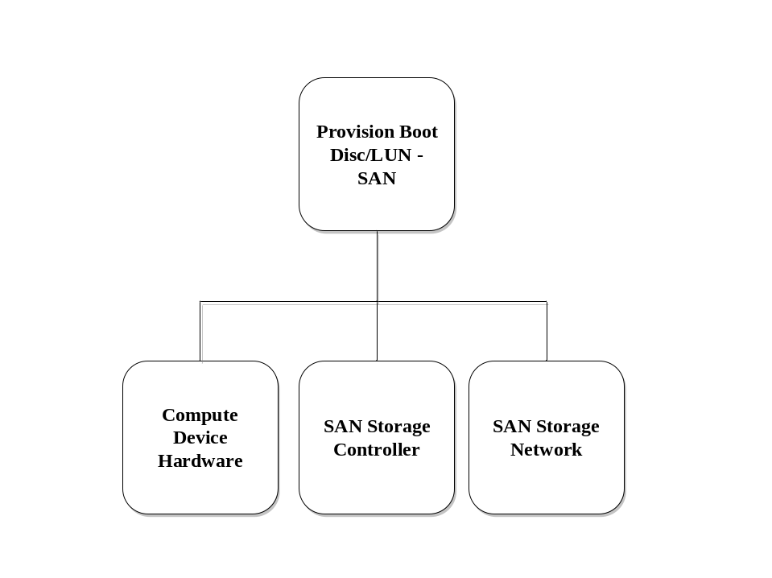
Figure 1 – Provision Boot Disk/LUN on SAN DAG

Basic Flow
- The Hardware Technician connects the compute device SAN network interface (HBA) to the SAN network and sets any necessary configuration options for the HBA.
- The Hardware Technician and The Storage Admin must provide the network addresses for the compute device HBA and the Storage controller port to complete the connection. For example for an FC SAN, the World Wide Port Numbers (WWPN) of the HBA and the Storage controller are needed.
- The Storage Admin configures a LUN partition (with the designated capacity) on the Storage controller to be used by the compute device to boot from. This configuration procedure is generally specific to the individual types of storage controller.
- For security reasons, it is usually necessary that the Storage Admin also setup the Compute device HBA network address (e.g. compute device HBA WWPN) in the Storage controller to only allow connections from the designated compute device to the boot LUN.
- The Hardware Technician then configures the compute device boot path to point to the designated SAN HBA, Storage network address (SAN controller WWPN), and disk LUN. Once the BIOS identifies the target boot LUN, the it looks for boot information to start the operating system boot process, for example by searching the disk for a Master Boot Record (MBR) or boot sector.
In the PC architecture the Master Boot Record (MBR), or partition sector, is the 512-byte boot sector, i.e. the sector on the logical beginning of a hard disk that contains the sequence of commands necessary for booting the operating system(s). The bootstrapping firmware contained within the ROM BIOS loads and executes the master boot record. The MBR of a drive usually includes the drive's partition table, which the PC uses to load and run the boot record of the partition that is marked with the active flag.
- Create a Master Boot Record or appropriate boot sector and allocate or divide the disk into partitions for the operating system's use utilizing a partition table manipulator, typically known as the fdisk utility.
- Format the partition(s), installing the appropriate file system on the media. Make a file system on the disk partition/partitions using the appropriate OS based tools.
- Attach the partitions to the file system. The mechanism for performing this action is OS specific. An operation of connecting partitions (to be more exact - connecting file systems) in Linux is called mounting and, as such, uses the command 'mount' to handle this. When mounting a partition in Linux, it needs to be associated with a directory somewhere in the file system. This is called creating a mount point. System configuration data may also need to be updated to automate the mounting of the drive on system startup.
- Inform the GME that this boot disk resource is available.

Alternative Flows
None

Exceptional Flows
None

Success Criteria
On power-on or reset the compute device will select the correct SAN disk path and attempt to boot the OS image from the correct disk LUN on the designated SAN controller.

Post Conditions
The system is ready to be provisioned with a bootable OS image on the SAN boot LUN.

Decommission Boot Disk/LUN - SAN

Summary
This use case captures the decommissioning of a boot LUN for use by a compute device for storing a bootable OS image. This frees the LUN or disk for use by other grid components. Releasing the LUN may require it to be scrubbed and for the GME repository to be updated.

Dependencies
The detailed steps depend on the type of OS, type of system, type of storage controller, and the type of network between the system and storage controller. These details of such specific dependencies are not described, although examples may be included.

Actor(s)/Stakeholder(s)
- System Admin
- Hardware Technician
- Storage Admin
- Network Admin
- Security Admin
- GME

Pre-Conditions
- A SAN based disk has been provisioned and is available for use by a compute device.
- All operation and application functions on the Compute device have been terminated
- The Compute device has been marked unavailable on the GME – i.e. not available for application use.

Initiation of Use Case
The System Admin request that the SAN attached boot LUN be decommissioned form the compute device.

Flow of Events
(Basic, Alternative and Exceptional)

Basic Flow
- Inform the GME that this SAN boot LUN resource is unavailable.
- Disconnect the partition. The mechanism for performing this action is OS specific. An operation of disconnecting partitions (to be more exact - disconnecting file systems) in Linux is called unmounting and, as such, uses the command 'umount' to handle this. When unmounting a partition in Linux, the association with the file system is removed at the mount point. System configuration data may also need to be updated to remove the auto-mounting of the drive on system startup.
- If required, scrub the partition(s), using the appropriate OS based tools if available. If no specific tools are available, utilize a partition table manipulator (fdisk) and the partition formatting tools to scrub the disk.
- Clear the BIOS path configuration information that points to the SAN boot LUN
- On the SAN storage controller delete the boot LUN configuration information. This configuration procedure is generally specific to the individual types of storage controller.
- If required, disconnect the SAN HBA from the SAN network.

Alternative Flows
None

Exceptional Flows
None

Success Criteria
The path to the SAN boot LUN has been cleared. The SAN boot LUN has (optionally) been scrubbed and has been removed from the SAN storage controller system. The SAN network has (optionally) disconnected from the Compute device SAN HBA.

Post Conditions
The compute device is back in the pre SAN boot provisioning state and cannot be booted.

Provision Boot Disk/LUN - NAS

Summary
This use case captures the provisioning of a boot file system for use by a compute device for storing a bootable OS image on a NAS storage server. This use case includes the logical configuration of the NAS file system on the NAS server system, and configuration of the compute device OBP or BIOS to be able to boot from it. In also involves the use of an intermediary PXE boot server to boot a pre-OS kernel that boots the target NAS boot image. The DAG for the bootable storage using NAS storage use cases is shown below in figure 7.3.
NAS
Network

Boot Disk/LUN
(NAS)

Compute
Device Hardware

NAS Controller
and Disks

PXE Server
Network

PXE Server

Figure 7.3: DAG showing dependencies for Bootable storage using NAS storage

Dependencies
The detailed steps depend on the type of OS, type of system, type of NAS server, and the type of network between the compute device and NAS server. These details of such specific dependencies are not described, although examples may be included.

Actor(s)/Stakeholder(s)
- System Admin
- Hardware Technician
- Storage Admin
- Network Admin
- Security Admin
- GME

Pre-Conditions
- The Compute Device is provisioned, and contains the required I/O devices to connect to the NAS network.
- The NAS server has been provisioned and is ready for individual client file systems to be created for NAS clients to use.
- The PXE/DHCP boot server is provisioned and running.
- The network connecting the compute device to the PXE boot server and NAS server is provisioned and is running.

Initiation of Use Case
Once the Hardware Technician has provisioned the compute device, the System Admin requests it be configured for NAS booting.

Flow of Events
(Basic, Alternative and Exceptional)
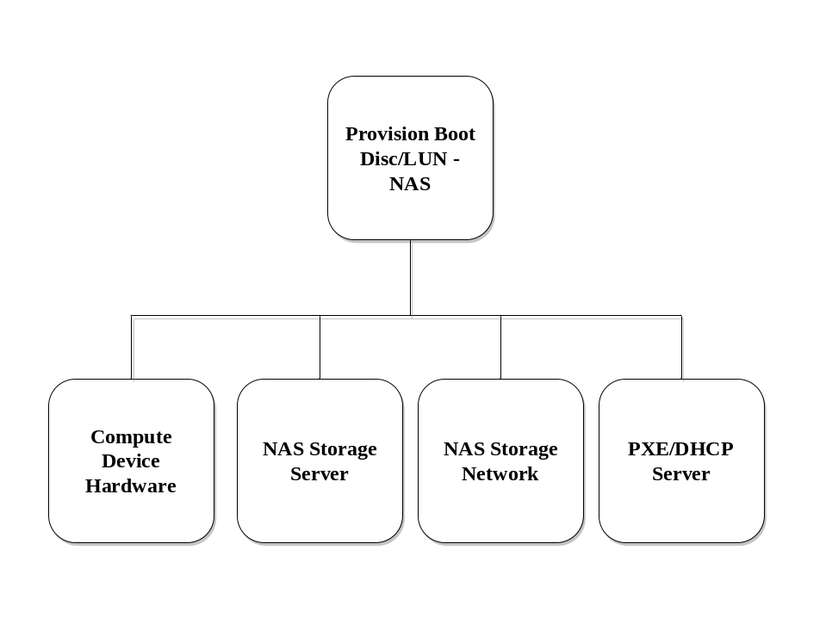
Figure 2 – Provision Boot Disk/LUN on NAS DAG

Basic Flow
- Hardware Technician connects the compute device network interface (HBA) to the NAS network and sets any necessary configuration options for the HBA.
- The Hardware Technician and The Storage Admin must provide the network addresses for the compute device HBA, the PXE/DHCP boot server, and the NAS server.
- The Storage Admin configures a NAS file system (with the designated capacity) on the NFS server to be used by the compute device to boot from. This configuration procedure is generally specific to the individual types of NAS server.
- The System Admin configures a pre-boot kernel on the PXE server for the network boot of the compute device. The pre-boot configuration includes the addresses (e.g. MAC address, and IP address) of the compute device boot network HBA.
- The Hardware Technician then configures the compute device boot path to point to the designated NAS HBA and to boot using a PXE network boot.
- Inform the GME that the NAS boot resource is available on the compute device.

Alternative Flows
None

Exceptional Flows
None

Success Criteria
On power-on or reset the compute device will select the correct network and attempt to boot the OS image from the correct NAS server and file system.

Post Conditions
The system is ready to be provisioned with a bootable OS image on the NAS storage file system.

Decommission Boot Disk/LUN - NAS

Summary
This use case captures the decommissioning of a boot LUN for use by a compute device for storing a bootable OS image. This frees the LUN or disk for use by other grid components. Releasing the disk may require it to be scrubbed and for the GME repository to be updated.

Dependencies
The detailed steps depend on the type of OS, type of system, type of storage controller, and the type of network between the system and storage controller. These details of such specific dependencies are not described, although examples may be included.

Actor(s)/Stakeholder(s)
- System Admin
- Hardware Technician
- Storage Admin
- Network Admin
- Security Admin
- GME

Pre-Conditions
- A NAS boot disk has been provisioned and is available for use by the compute device.
- All operation and application functions on the Compute device have been terminated
- The Compute device has been marked unavailable on the GME – i.e. not available for application use.

Initiation of Use Case
The System Admin request that the NAS boot disk be decommissioned form the compute device.

Flow of Events
(Basic, Alternative and Exceptional)

Basic Flow
- Inform the GME that this NAS boot disk resource is unavailable.
- Disconnect the NAS file system. The mechanism for performing this action is OS specific. An operation of disconnecting partitions (to be more exact - disconnecting file systems) in Linux is called unmounting and, as such, uses the command 'umount' to handle this. When unmounting a partition in Linux, the association with the file system is removed at the mount point. System configuration data may also need to be updated to remove the auto-mounting of the drive on system startup.
- If required, scrub the file system on the NAS server using the appropriate OS based tools if available.
- Clear the BIOS path configuration information that selects the PXE boot and NAS network HBA path.
- Clear the PXE boot information for the designated compute device on the PXE server.
- On the NAS server remove the NAS file system for the designated compute device. This configuration procedure is generally specific to the individual types of NAS server.
- If required, disconnect the NAS HBA from the NAS network.

Alternative Flows
None

Exceptional Flows
None

Success Criteria
The path to the NAS network HBA and PXE boot has been cleared. The NAS boot file system has (optionally) been scrubbed and has been removed from the NAS server system. The NAS network has (optionally) disconnected from the Compute device NAS HBA.

Post Conditions
The compute device is back in the pre NAS boot provisioning state and cannot be booted.

Provisioning Virtual Machine Managers

Provision VMM To Physical Server

Summary
This use case describes the provisioning, installation, of Virtual Machine Monitor software to a physical server or hardware partition. Based on implementation of GME, GME could be responsible for checking the image certification for each VMM type in respect to Physical Server before deployment. VMM Media/Software covered in this use cases are Para-Virtualized and Classic Virtual Machines as shown in figure 1.
Figure 1
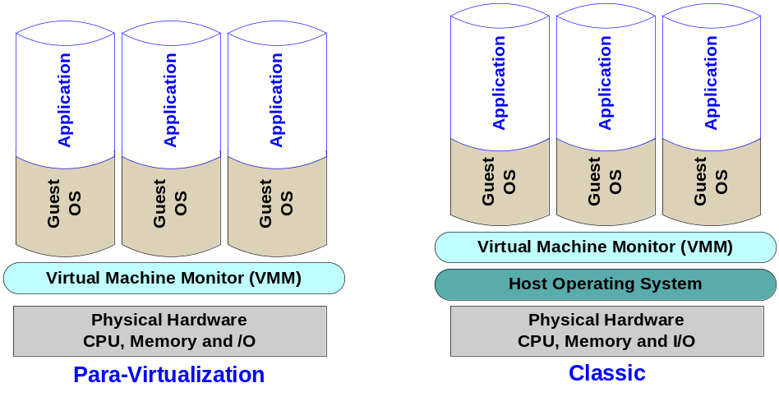
Classic VMM emulate the low level platform API and therefore require a Host operating system while Para-Virtualized VMM provide high level platform API and requires modification to the Guest operating systems*.
Section 7.3.6 Basic flow will describes the provisioning of Para-Virtualized VMM. Section 7.3.6 Alternative flow describes the provisioning of Classic VMM. The VMM software configuration can be done after installation or could be done as part Media/Software creation process. In this use case we assume the VMM Media/Software are configured and certified for specific hardware before their submission to GEM for deployment.
Note: Physical Server that supports hardware assist virtualization technologies does not require Guest OS modification

Dependencies
A physical server is available and ready to be provisioned as defined in the pre-conditions below.
1. If required by VMM, enable server platform specific virtualization assistant features during boot process
2. GME VMM management tools is available and operational

Actor(s)/Stakeholder(s)

- The primary actors are:
  - Data Center Server admin
  - GME
- Secondary actors which may act on behalf of the GME include:
  - Data Center System Admin
  - Data Center Admin
  - Data Center Manager
  - Data Center DBA
  - Data Center Network Admin
  - Data Center Storage admin
  - Data Center Server admin
  - Data Center Security Admin

Pre-Conditions
- The VMM media steps from use case 7.35 has been successfully completed
- Check for type of VMM and their specific software and hardware dependencies
- The physical server has been setup according to use case 8.4

Initiation Of Use Case
A physical server is added to the data center, an existing system was recycled or the GME demands an additional resource based on SLA or Policy.

Flow Of Events
(Basic, Alternative And Exceptional)

Basic Flow
- In the GME, assign the appropriate VMM media and preboot bundle to the hardware.
- Configure system for PXE preboot.
- Power on the system.
- For VMM that require hardware virtualization assist, enable the feature
- System retrieves the new system IP address plus the name of the preboot file it should use and the address of the PXE boot server.
- System requests the preboot file from the PXE boot server. The boot server responds, typically via TFTP.
- System loads the preboot file (aka boot loader) into memory and executes it.
- Hardware detection is performed and the boat loader executes according to the configuration data information (aka image safe data).
- (Optional) PXE menu configuration is requested and displayed on the System console.
- (Optional) The boot loader may check the GME to see if any “work” is assigned to the pre loader process.
- If work is assigned, the boot loader retrieves the assigned work from the GME policy daemon.
- The System requests and receives the VMM media (aka OS, VMM, and tools) from the service described in the VMM media as per use case X. 35.
- (Optional) The assigned GME work is executed.
- The VMM image is installed on the System.
- The system is rebooted and VMM is running.

Alternative Flows
In case of provisioning a classic VMM a Host Operating System required. To provision OS to a Physical Server review section 9.1.6
- In the GME, assign the appropriate VMM media and preboot bundle to the hardware.
- Configure system for PXE preboot.
- Power on the system.
- For VMM that require hardware virtualization assist, enable the feature
- System retrieves the new system IP address plus the name of the preboot file it should use and the address of the PXE boot server.
- System requests the preboot file from the PXE boot server. The boot server responds, typically via TFTP.
- System loads the preboot file (aka boot loader) into memory and executes it.
- Hardware detection is performed and the boat loader executes according to the configuration data information (aka image safe data).
- (Optional) PXE menu configuration is requested and displayed on the System console.
- (Optional) The boot loader may check the GME to see if any “work” is assigned to the pre loader process.
- If work is assigned, the boot loader retrieves the assigned work from the GME policy daemon.
- The System requests and receives the VMM media (aka VMM, and tools) from the service described in the VMM media as per use case X. 35.
- (Optional) The assigned GME work is executed.
- The VMM image is installed on the Host Operating System.
- The system is rebooted and VMM is running.

Exceptional Flows

Success Criteria
The physical resource has been provisioned and installed and ready to be used, such that the resource is now visible to the GME.

Post Conditions
The resource is available, visible to the GME but idle.

Decommission VMM from Physical Server

Summary
This use case describes the removal/decommissioning of a Virtual Machine Monitor from a server or hardware partition. Nothing is assumed about the initial state of the VMM, or pf those components which may be bound to it or which may depend upon it.

Dependencies
The server is accessible via the GME.
- GME determine that all dependent applications/data on this resources are moved to other resources or gracefully disabled

Actor(s)/Stakeholder(s)

- The primary actors are:
  - Data Center Server admin
  - GME
- Secondary actors which may act on behalf of the GME include:
  - Data Center System Admin
  - Data Center Admin
  - Data Center Manager
  - Data Center DBA
  - Data Center Network Admin
  - Data Center Storage admin
  - Data Center Server admin
  - Data Center Security Admin

Pre-Conditions
- Due to a policy or SLA requirement by GME the physical resource to be recycled.

Initiation of Use Case
GME Policy requires that the physical resource should be decommissioned and recycled.

Flow Of Events
(Basic, Alternative And Exceptional)
<DAG>

Basic Flow
- The administrator informs the GME that this resource is now unavailable.
- The resource terminates all services gracefully.
- The administrator utilizes the steps from use case 7.23 to remove the VMM, subsequent OS (s) and tools from the system.

Alternative Flows

Exceptional Flows

Success Criteria
The VMM/OS image has been removed.

Post Conditions
The system is ready to be recycled or removed from GME available resources directory

Post Conditions
<Text>

Provisioning Virtual Servers

Provision Virtual Server

Summary
This use case describes the creation or provisioning of a virtual server (Guest OS) on a virtual machine monitor (VMM) as shown in figure 1

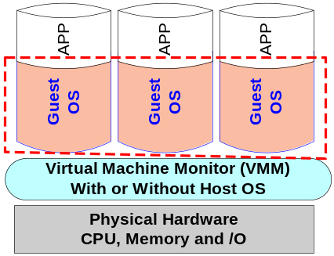
Figure 1
Virtual Server (Guest OS) is fully functional operating system image. Para-Virtualized VMM without hardware assist technology require modified Guest OS, otherwise unmodified Guest OS will be installed. Classic VMM do not require modified Guest OS.

Dependencies

Provision OS Media: Use case 7.20
- Provision Physical Compute Device (Server): Use case 7.5
- Decommission OS Media: Use case 7.21
- Provision VMM Media: Use case 7.3.1 and 7.3.2
- Provision VMM Media to a Physical Server: Use case 7.3.6
- Provision Boot Disk/LUN – Local Disk: Use case 7.14
- Provision Boot Disk/LUN – SAN: Use case 7.16
- Provision Boot Disk/LUN – NAS: Use case 7.18

Actor(s)/Stakeholder(s)
- The primary actors are:
  - Data Center Server admin
  - GME
- Secondary actors which may act on behalf of the GME include:
  - Data Center System Admin
  - Data Center Admin
  - Data Center Manager
  - Data Center DBA
  - Data Center Network Admin
  - Data Center Storage admin
  - Data Center Server admin
- Data Center Security Admin

Pre-Conditions
- VMM Media provisioned to Physical server
- VMM is configured according to software and Hardware specification
- VMM is fully operational and ready for deployment

Initiation Of Use Case
Based on Policy, SLA or maintenance requirements GME determines an additional new Virtual Server (Guest OS) is required to host a service in order to meet SLA or Policy.

Flow Of Events
(Basic, Alternative And Exceptional)
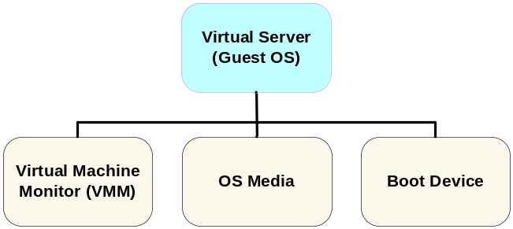
Referring to Figure above, Provisioning Virtual Server (Guest OS) to Server DAG. In order to provision an active Virtual Server (Guest OS) the DAG must be traversed as described in the general grid component provisioning use case above.

Basic Flow
- Create new or discover Virtual Server (Guest OS) image in GME reposirtory.
- Configure Virtual Server (Guest OS)
- Create or Retrieve bootable image from boot device for server component.
- Configure OS management network, not necessarily same as console port and network.
- Configure Virtual Server (Guest OS) with appropriate policies etc.
- Update GME to reflect Virtual Server (Guest OS) is inactive.
- Start Virtual Server (Guest OS)
- Activate Virtual Server (Guest OS)
- Update GME to reflect Virtual Server (Guest OS) is active.
- Decommission OS Media (optional)
Follow the steps in use case 7.21, Decommission OS Media. This may or may not be done after activating the Virtual Server (Guest OS). If the Guest OS image is physically copied from the OS Media to the boot device, the OS media can now be decommissioned.

Alternative Flows
Many other flows are possible depending on the starting states of the various grid components. For example the boot device could be a local storage device within a server and thus may need different configuration steps/actions.
Also some of the state changes for individual grid components may be interleaved as their creation, configuration and activation may be carried out in parallel.

Exceptional Flows
Exceptions would be generated if the appropriate grid components (e.g. Correct Guest OS or VMM media) are not available, or any of the steps generate errors, or the performance metric objectives are not met.

Success Criteria
Virtual Server (Guest OS) is provisioned

Post Conditions
Virtual Sever is active, operational and ready for deployment by GME

Decommission Virtual Server

Summary
This use case describes the removal of a virtual machine or server from a VMM. Nothing is assumed about the state of the Virtual Server (Guest OS), nor of any grid components which are bound to it or which depend upon it.

Dependencies

- Decommission Boot Disk/LUN – Local Disk: See use case 7.15
- Decommission Boot Disk/LUN – SAN: See use case 7.17
- Decommission Boot Disk/LUN – NAS: See use case 7.19

Actor(s)/Stakeholder(s)
- Primary actor is GME
- Secondary actors which may act on behalf of the GME include:
  - Data Center System Admin
  - Data Center Admin
  - Data Center Manager
  - Data Center DBA
  - Data Center Network Admin
  - Data Center Storage admin
  - Data Center Server admin
  - Data Center Security Admin

Pre-Conditions
- The workload or service hosted by the Virtual Server (Guest OS) has terminated
- There is no longer a reservation for this Virtual Server in the GME repository

Initiation of Use Case
The GME detects that the reservation for this Virtual Server that assigned it to a service has been cancelled.

Flow Of Events
(Basic, Alternative And Exceptional)
- Stop Virtual Server (Guest OS)
  - Stop all services using this Virtual Server
  - Shutdown the Virtual Server (Guest OS)
  - Update GME to reflect Virtual Server (Guest OS) inactive
- Decommission Boot Disk/LUN:
  - If boot disk is local, follow steps in use case 7.15
  - If boot disk is on a SAN, follow steps in use case 7.17
  - If boot disk is on a NAS, follow steps in use case 7.19
- Remove Virtual Server (Guest OS)
Update the VMM configuration in the GME repository to reflect that Virtual Server (Guest OS) grid component removed.

Alternative Flows
- If a Virtual Server (Guest OS) is already shut down, then skip step 1 (a & b).

Exceptional Flows
- GME will verify no services are active on Virtual Server (Guest OS)
- If the OS fails to shutdown, flag the Virtual Server (Guest OS) for diagnostic tests.

Success Criteria
The Virtual Server (Guest OS) has been shut down, and is not associated with an VMM

Post Conditions
The VMM is ready to be provisioned to another Virtual Server (Guest OS) and service, or has been flagged disabled due to SLA, policy or maintenance requirement.

Provisioning Operating Systems

Provision An OS Instance To A Server

Summary
To realize the benefits of grid computing, it is important to be able to provision and de-provision services, as your business needs change. This use case deals with provisioning a server (including an operating system) in an enterprise grid in order to meet the SLOs and/or constraints of a service or business application.

Dependencies
This use case is dependent on, i.e. it calls the following use cases:

Provision OS Media: Use case 9.1
- Provision Physical Compute Device (Server): Use case 2.4
- Provision Boot Disk/LUN – Local Disk: Use case 6.1

Actor(s)/Stakeholder(s)
- Primary actor is GME
- Secondary actors which may act on behalf of the GME include:
  - Data Center System Admin
  - Data Center Admin
  - Data Center Manager
  - Data Center DBA
  - Data Center Network Admin
  - Data Center Storage admin
  - Data Center System admin
  - Data Center Security Admin

Pre-Conditions
- The various grid components, as enumerated in the DAG are manageable by the GME. For a physical component (e.g. server, drive array, network switch/router, software distribution media), this means that it must be at the enterprise grid’s physical location. For all other grid components, it means that they must be logically manageable by the GME.
- All SLOs and constraints for the grid components have been defined. Depending on the particular type of grid component this may range from simple parameters such as the number of processors to be used by an application, to the high level business SLOs (e.g. average transaction response time) which map directly to the SLA for the grid component which is a complete business application. It is the role of the GME to derive component goals from those of aggregated sets of components or more abstract components such as business applications or services.
- Use of the grid component and its intended deployment has been appropriately licensed or will be appropriately licensed in parallel to the provisioning process.
Note – it may be appropriate for future iterations of this document to more clearly capture the licensing process as this is a key, long-term enabler for utility computing environments and may be closely bound to the utility accounting process.

Initiation Of Use Case
The GME determines an additional server, and associated operating system, is required to host a service in order to meet SLOs.

Flow Of Events
(Basic, Alternative And Exceptional)
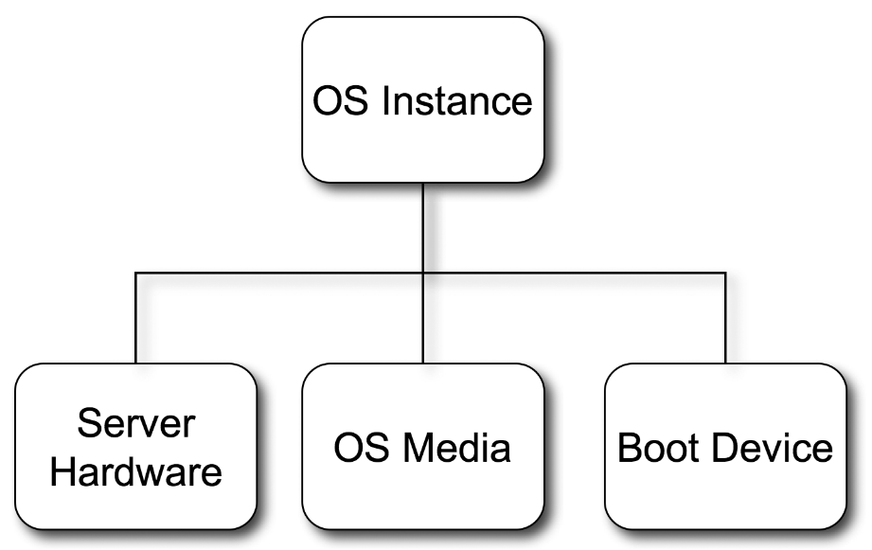
Figure 1 – Provision OS Instance to Server DAG

Basic Flow
Referring to Figure 1, Provisioning OS Instance to Server DAG, above. In order to provision an active OS instance, the DAG must be traversed as described in the general grid component provisioning use case above.
- Provision Physical Compute Device (Server)
Follow procedures in use case 2.4
- Provision OS media grid component
Follow the steps in use case 9.1, Provision OS Media.
- Provision Boot Disk/LUN
- If boot disk/LUN is local, follow steps in use case 6.1
- If boot disk/LUN is on a SAN, follow steps in a future use case
- If boot disk/LUN is NAS, follow steps in a future use case
- Create/Discover OS instance Grid Component
Create new OS instance grid component in GME—status is unconfigured.
- Configure OS Instance Grid Component
- Create bootable image on boot device for server component.
- Configure OS management network, not necessarily same as console port and network.
- Configure OS instance with appropriate policies etc.
- Update GME to reflect OS Instance grid component is inactive.
- Start OS Instance Grid Component
- Activate OS instance.
- Update GME to reflect OS Instance Grid Component is active.

Alternative Flows
Many other flows are possible depending on the starting states of the various grid components. For example the boot device could be a local storage device within a server and thus may need different configuration steps/actions.
Also some of the state changes for individual grid components may be interleaved as their creation, configuration and activation may be carried out in parallel.

Exceptional Flows
Exceptions would be generated if the appropriate grid components are not available, or any of the steps generate errors, or the performance metric objectives are not met.

Success Criteria
The specified grid component is activated.

Post Conditions
The grid component is active and available for the GME to deploy other grid components or services on to.

Reboot OS

Summary
This use case will reboot the operating system from a server.

Dependencies
This use case is dependent on the following use cases (for exception handling only):
- Decommission OS Instance from Server: See section 9.5
- Provision OS Instance from Sever: See section 9.3

Actor(s)/Stakeholder(s)
- Primary actor is GME
- Secondary actors which may act on behalf of the GME include:
  - Data Center System Admin
  - Data Center Admin
  - Data Center Manager
  - Data Center DBA
  - Data Center Network Admin
  - Data Center Storage admin
  - Data Center System admin
  - Data Center Security Admin

Pre-Conditions
The workload or service hosted by the server has terminated

Initiation Of Use Case
System Admin or GME must determines system must be rebooted.

Flow Of Events
(Basic, Alternative And Exceptional)
Figure 2 – Reboot Server DAG

Basic Flow
- Update GME to reflect OS instance is inactive
- Run reboot script for OS instance
- Update GME to reflect OS Instance is Active

Alternative Flows
Many other flows are possible depending on the starting states of the various grid components. For example the boot device could be a local storage device within a server and thus may need different configuration steps/actions.
Also some of the state changes for individual grid components may be interleaved as their creation, configuration and activation may be carried out in parallel.
If no reboot script exists, then run the shutdown script and restart the system.
If the OS Instance is stopped, start the system.

Exceptional Flows
Exceptions would be generated if the appropriate grid components are not available, or any of the steps generate errors, or the performance metric objectives are not met.
If either step 1 or step 2 fail, then follow this exception flow.
- Decommission the OS Instance as described in use case 9.5
- Commission a new OS Instance as described in use case 9.3.

Success Criteria
The specified grid component is activated.

Post Conditions
The grid component is active and available for the GME to deploy other grid components or services onto.

Decommission OS Instance From Server

Summary
This use case will decommission the operating system from a server that is no longer needed to host a service. This will prepare the grid components for reuse by another service.

Dependencies
None

Actor(s)/Stakeholder(s)
- Primary actor is GME
- Secondary actors which may act on behalf of the GME include:
  - Data Center System Admin
  - Data Center Admin
  - Data Center Manager
  - Data Center DBA
  - Data Center Network Admin
  - Data Center Storage admin
  - Data Center System admin
  - Data Center Security Admin

Pre-Conditions
- The workload or service hosted by the server has terminated
- There is no longer a reservation for this server in the GME repository

Initiation Of Use Case
The GME detects that the reservation for this server that assigned it to a service has been cancelled.

Flow Of Events
(Basic, Alternative And Exceptional)
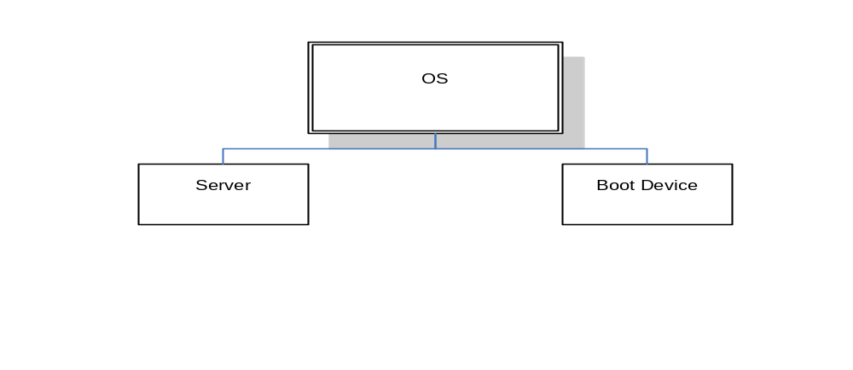

Figure 3 - Decommission OS Instance from Server DAG

Basic Flow
- Stop OS Instance Grid Component
  - Run shutdown script for server
  - Update GME to reflect OS Instance inactive
- Unconfigure OS Instance Grid Component
  - Remove the bootable image from the boot device
  - Update GME to reflect OS Instance unconfigured
- Destroy OS Instance Grid Component
Update the server configuration in the GME repository to reflect the OS instance grid component is destroyed.

Alternative Flows
- If a server is already shut down, then skip step 2.

Exceptional Flows
- GME will verify no services are active on any server. If a server is hosting an active service, the operation on that server will fail.
- If the OS fails to shutdown, then power cycle server and continue with step 3.
- If any steps fail, flag the server for diagnostic tests.

Success Criteria
The server has been shut down, and is not associated with an operating system

Post Conditions
The server is ready to be provisioned to another operating system and service, or has been flagged disabled due to hardware fault.

Provisioning Patches

Provision Patch

Summary
This use case describes the process associated with the application of a patch to an operating environment, application, or other grid component. Nothing is assumed about the starting state of the component or about the grid components bound to the OS or which depend upon it. The patch media is assumed to have already been provisioned.

Dependencies
- Provision patch media – see use case 10.1.

Actor(s)/Stakeholder(s)
- System admin
- Network Admin
- Storage Admin
- Security Admin
- GME

Pre-Conditions
- The GME exists.
- The GME repository exists.

Initiation Of Use Case
Provisioning of a patch is requested. This may be for any reason, ranging from a notification from a software vendor to an in-house patch for some known problems.

Flow Of Events
(Basic, Alternative And Exceptional)

Basic Flow
There are two basic types of patches. Online patches can be discovered and configured while the grid component is active, and the component only needs to be restarted (stopped and started) in order to active the patch. Offline patches cannot be discovered and configured while the target grid component is active. It must be stopped prior to starting discovery, and started upon completion of patch configuration. For this use case, offline patches will form the basic flow, and online patches will be treated as an alternative flow.
- Create/Discover the patch
  - GME checks whether the patch is compatible with the component on which it is to be provisioned.
  - GME checks for dependencies—for example, other grid components that must also be patched. An example would be other components that make up a clustered service. All instances of the service may need to be patched at the same time.
  - GME downloads the patch to the specified node(s).
  - GME stops any running applications, and updates repository. (This may be another use case.)
  - GME makes the node unavailable during the provisioning process, by updating the information repository.
  - GME starts the specified node(s) with the right privilege level, if needed.
  - Patch is now unconfigured
- Configure the patch
  - GME configures the system, and the installation scripts for correct installation.
  - GME starts the scripts for installing the patch.
  - GME checks the log files for correct installation.
  - GME repeats steps 4) - 7) if the installation was not successful as specified by a policy engine.
  - GME updates its repository.
  - Patch is now inactive
- Start the patch
  - GME makes patched component available for use. This usually requires restarting the component, but not always
  - GME sends a notification to the subscribed users about the new patch.
  - Patch is now active
- GME restarts dependent applications on the patched node. (This may be another use case.)

Alternative Flows
If the patch media does not exist, provision the patch media as in use case 10.1.
If patch is online, then steps 1e and 1f are moved to before step 3a.

Exceptional Flows
If any steps fail then they are repeated for a specified number of times until successful, or a notification is sent to the system admin, as specified by a policy engine.

Success Criteria
The new patch has been installed on the specified nodes in the grid, and relevant info added into the repository of the GME, and a notification sent to the subscribed stakeholders.

Post Conditions
The new patch has been installed on the specified nodes in the grid, and relevant info added into the repository of the GME.

Decommission (Roll back) Patch

Summary
This use case describes the process by which a patch is rolled back. This is usually done through rolling back to a backed up version of the OS. Nothing is assumed about other grid components that are bound to the OS instance or which depend upon it. Nothing is assumed about the state of the OS instance (bound, not bound, running, configured etc.).

Dependencies
None

Actor(s)/Stakeholder(s)
- System admin
- Network Admin
- Storage Admin
- Security Admin
- GME

Pre-Conditions
- The GME exists.
- The GME repository exists.
- The patch exists on the node.

Initiation Of Use Case
Decommissioning of a patch is requested. This may be for any reason, e.g., software compatibility of an existing application.

Flow Of Events
(Basic, Alternative And Exceptional)

Basic Flow
- GME checks whether the patch is already installed on the system on which it is to be decommissioned.
- GME updates the information repository and makes the node to be decommissioned as unavailable during the decommissioning process.
- GME updates information repository about dependencies, relevant reasons etc.
- GME stops any running applications, and updates repository. (This may be another use case.)
- GME starts the specified node(s) with the right privilege level, if needed.
- GME configures the system, and the installation scripts for correct decommissioning.
- GME starts the scripts for decommssioning the patch.
- GME checks the log files for correct decommissioning.
- GME repeats steps 6) - 8) if the decommissioning was not successful as specified by a policy engine.
- GME updates its repository.
- GME makes decommissioned node available for use.
- GME sends a notification to the subscribed users about the decommissioned patch.
- GME restarts applications on the patched node. (This may be another use case.)

Alternative Flows
Try a manual decommission of the patch.

Exceptional Flows
If any steps fail then they are repeated for a specified number of times until successful, or a notification is sent to the system admin, as specified by a policy engine.

Success Criteria
The patch has been decommissioned on the specified node in the grid, and relevant info added into the repository of the GME, and a notification sent to the subscribed stakeholders.

Post Conditions
The patch has been decommissioned on the specified node in the grid, and relevant info added into the repository of the GME.

Provisioning Pools Of Servers (Physical & Logical)

Create Pool Of Compute Devices (Servers) Object

Summary
This use case describes the process of creating a pool of servers. The pool is explicitly created to enable group functions to be undertaken on the members. The pool may be short or long lived depending on the function or set of functions to be applied to its members. Membership of the pool may be completely open and based solely on choices made by the system admin, or qualification through some set of shared properties or shared state may be stipulated.
The create pools use case does not result in any components or servers being members of the pool. It merely results in the pool existing as an abstract entity within the GME. The servers may be physical or logical, but all must be essentially identical in terms of behaving in the same way when a specific verb or action (the reason for aggregation) is applied to them, for example provision OS, or start OS or whatever.

Dependencies
None

Actor(s)/Stakeholder(s)
- System admin
- GME

Pre-Conditions
- The GME exists.

Initiation Of Use Case
A system admin needs to create a pool of components, in this case a pool of servers (physical or logical compute devices, i.e. virtual machines hosted by a VMM), in order to manage them collectively, thus realizing management efficiency gains.

Flow Of Events
(Basic, Alternative And Exceptional)

Basic Flow
- The system admin creates the pool object within the GME repository.
- The system admin defines the initial properties of the pool. These could include minimum and maximum number of pool members for example, a user friendly name and so forth.
- The system admin saves the set of initial pool attributes and properties to the GME repository.
- The system admin defines a set of membership criteria for the pool. These could range from none, so that an appropriately authorized admin may add any server they like to the pool, to restrictions on specific server properties, such as processor architecture, memory capacity, storage connectivity and so forth. These criteria could be used to filter servers and create a candidate set from which an admin could choose, or they could be used as a cross check once initial selections have been made.
- The system admin saves the set of membership criteria to the GME repository.
- The system admin defines the set of verbs that may be applied to the members of the pool, for example provision firmware or provision operating system etc. The choice of verbs may be tightly coupled with the membership criteria. For example, if firmware media provisioning were to be enabled, then all of the members of the pool would need to support firmware upgrades.
- The system admin saves the set of verbs to the GME repository.
- The system admin defines the set of roles associated with managing the pool. Such roles could include roles for adding and removing members of the pool, and roles associated with applying specific verbs to the pool.
- The system admin saves the set of roles to the GME repository.
- The system admin defines the set of policies associated with managing the pool. Such policies could include, for example, what actions to take in the event of exceptions during aggregate operations in the pool membership.
- The system admin saves the set of policies to the GME repository.
- The system admin updates the GME repository to indicate that the pool is now available for use.

Alternative Flows
Steps 2 and 3 – These may be ignored and default values assumed.
Steps 4 and 5 – These may be ignored and default values assumed.
Steps 6 and 7 – These may be ignored and default values assumed.
Steps 8 and 9 – These may be ignored and default values assumed.
Steps 10 and 11 – These may be ignored and default values assumed.

Exceptional Flows
If any of the steps fail then the pool object is not available for use. Steps may be repeated until the system admin decides to back out, removing the pool object from the GME repository.

Success Criteria
The GME repository indicates that the pool is available for use.

Post Conditions
- The server pool object exists in the GME repository.
- The properties and constraints of the pool have been set in the GME repository.
- Any membership criteria, beyond simple admin assignment, have been set in the GME repository.
- The set of verbs that may be applied to the pool has been defined in the GME repository.
- The roles associated with management of the pool have been defined in the GME repository.
- The policies associated with managing the pool have been defined in the GME repository.

Decommission Pool Of Compute Devices (Servers) Object

Summary
This use case describes the process of decommissioning a pool of compute components object, not necessarily the decommissioning of the servers themselves. When this use case is initiated the pool may or may not have members. Whilst the pool may no longer be available for actions to be undertaken on the membership, it will persist within the GME for record keeping and with respect to logging. Thus the decommissioning may be incomplete

Dependencies
- Remove Physical Server From Pool Object, see section 11.5.

Actor(s)/Stakeholder(s)
- System admin
- GME

Pre-Conditions
- The pool is available.

Initiation Of Use Case
This use case is initiated when the system admin no longer requires the pool to exist, for example because the pool is empty or is no longer relevant as a unit of manageability.

Flow Of Events
(Basic, Alternative And Exceptional)

Basic Flow
- The system admin selects the pool within the GME repository.
- The system admin removes each remaining member of the pool. See section 11.5, Remove Physical Server From Pool Object.
- The system admin marks the pool object as unavailable in the GME repository.

Alternative Flows
Step 2: Ignore if there are no members of the pool.

Exceptional Flows
Repeat steps until 3) succeeds or the system admin gives up.

Success Criteria
The pool is marked as unavailable.

Post Conditions
- The pool object exists within the GME repository.
- The pool object has no members.
- The pool object is no longer available – that is no members may be added or removed, and no verbs may be applied to the pool.

Monitor & Manage Pool Object

Summary
This high-level use cases captures the general monitoring and management of the pool object and not the aggregate functions on the membership of the pool. Supported monitoring and management functions supported include, but are not necessarily limited to –
- Find grid object
- Set/get pool object properties/attributes
- Set/get pool membership constraints
- Set/get pool related policies
- Set/get pool verbs
- Set/get pool roles

Dependencies

11.1 Create Pool Of Compute Devices (Servers) Object
11.2 Decommission Pool Of Compute Devices (Servers) Object
11.4 Add Physical Server To Pool Object
11.5 Remove Physical Server From Pool Object
11.6 Grant Admin Rights To Pool
11.7 Rescind Admin Rights From Pool
11.8 Set Pool Derived Policy
11.9 Set Pool Constraints
11.10 Set Pool Configuration
11.11 Get Pool Policy
11.12 Get Pool Configuration
11.13 Get Pool Billing & Accounting
11.14 Select From Pool Members
11.15 Provision Firmware To Pool
11.16 Decommission Firmware On Pool
11.17 Provision OS To Pool
11.18 Decommission OS On Pool
11.19 Set State Of Pooled Servers
11.20 Get State Of Pooled Servers
11.21 Provision Patch To Pool
11.22 Decommission Patch From Pool

Actor(s)/Stakeholder(s)

- Installation Engineer
- Server Admin
- Network Admin
- Server Admin
- Security Admin
- GME

Pre-Conditions

- The GME exists.
- The GME repository exists.
- The GME daemons exist on the device.

Initiation Of Use Case

The required daemons are started/configured on the server, and metadata about valid pool definitions is added to the GME repository. Pools to be managed are operational with proper patches and firmware and their policies, configurations and constraints set appropriately.

Flow Of Events
(Basic, Alternative And Exceptional)

Basic Flow
- Initiate desired monitor/manage functionality (such as get/set/change pool configurations and policies).
- Update the GME information repository to reflect the new Pool State.
- Send a notification to the system admin

Alternative Flows

Step 1: If the necessary monitor/manage operation is already executional, then the corresponding steps may be skipped and a message is sent to the system admin.

Exceptional Flows
If any steps fail then they are repeated until successful, or a notification is sent to the system admin, as specified by a policy engine.

Success Criteria
Desired monitor/manage functionality (such as get/set/change pool configurations and policies) is effectively delivered and the GME information repository is updated to reflect the modified Pool.

Post Conditions

Pool/s with new specified configurations/policies are operational and are being monitored effectively.

Add Physical Server To Pool Object

Summary
This use case describes the process involved in adding a physical compute device (server) to a pool.

Dependencies
This use case depends upon the following use cases –
- Use case 2.4, Provision Physical Compute Device

Actor(s)/Stakeholder(s)
- Hardware Technician
- System admin
- Network Admin
- Storage Admin
- System admin
- Security Admin
- GME

Pre-Conditions
- The GME exists.
- The GME repository exists.
- The GME daemons exist on the device.

Initiation Of Use Case
The required daemons are started/configured on the server, and metadata about addition of the specified server is added to the GME repository.

Flow Of Events
(Basic, Alternative And Exceptional)

Basic Flow
- Provision the server as in use case 2.4
- Configure, and run necessary daemons on the server node
- Update the GME information repository
- Send a notification to the system admin

Alternative Flows
Step 1: If the server is provisioned, this can be skipped.
Step 2: If the necessary daemons are already configured/running, then the corresponding steps may be skipped. If the server is already a member of the specified pool, this info is logged, and a message is sent to the system admin. If the server is already a member of another pool, an error message is generated, and the info is logged, and a message sent to the system admin.

Exceptional Flows
If any steps fail then they are repeated until successful, or a notification is sent to the system admin, as specified by a policy engine.

Success Criteria
The specified physical server has been added to the specified pool object, required daemons have been configured/started on the server, the GME repository updated, and a notification sent to the system admin.

Post Conditions
The server is now a part of a pool.

Remove Physical Server From Pool Object

Summary
This use case describes the process involved in removing a physical server from a Pool Object.

Dependencies
This use case depends upon the following use cases –
- Use case 9.5, Decommission Operating System Instance

Actor(s)/Stakeholder(s)
- Hardware Technician
- System admin
- Network Admin
- Storage Admin
- Security Admin
- GME

Pre-Conditions
- The GME exists.
- The GME repository exists.
- The GME daemons exist on the device.
- Desired Pool is formed with proper resources.

Initiation Of Use Case
The applications running on the server are stopped, and the metadata about the removal of the specified server is updated in the GME repository.

Flow Of Events
(Basic, Alternative And Exceptional)

Basic Flow
- Verify the Pool Definition and its current implementation.
- Verify that the physical server to be removed belongs to the Pool.
- Gracefully shut down the Physical server to be removed, as described in use case 9.5
- Remove the Physical Server from the Pool.
- Update the Pool Configuration State Vector in the GME repository.
- Send a notification to the system admin.

Alternative Flows

Step 1: If the physial server is non-operational already due to hardware/power failure, update the Pool Configuration State vector in the GME repository and start the revovery procedures, if mandated by the SLAs.

Exceptional Flows
If any steps (1-6) in the basic flow fail, a notification is sent to the system admin and GME, as specified by a policy engine.

Success Criteria
The Pool Configuration State Vector (which denotes the constituent resources and their states) has been updated to the GME repository and a notification sent to the system admin.

Post Conditions
The physical server is removed from the Pool and the Pool State vector is updated.

Grant Admin Rights To Pool

Summary

Pool of compute devices is formed. This use case grants administration rights such as pool membership/s, access and operations rights to the Pool.

Dependencies
None

Actor(s)/Stakeholder(s)
- GME
- System admin

Pre-Conditions
- GME exist
- GME repository exist
- The various grid components, as enumerated in the DAG are manageable by the GME.
- All SLOs for application services have been defined
- All SLOs and constraints for the grid components have been defined
- Use of the grid component and its intended deployment has been appropriately licensed or will be appropriately licensed in parallel to the provisioning process
- The pool has been created and is available.

Initiation Of Use Case
After the Pool of compute devices is formed, the Pool is set to get admin rights to facilitate operations such as adding servers, applying OS, firmware and patches and pool state management.

Flow Of Events
(Basic, Alternative And Exceptional)

Basic Flow
- Verify the Pool Definition and its current implementation.
- Make sure the Pool is operational.
- Update Pool Metadata to reflect new Pool Admin Capabilities.
- Add the updated Pool Metadata to the GME repositoty.
- Send a notification to the system admin.

Success Criteria
- Pool has desired Admin Rights.
- GME repository is updated

Post Conditions
Pool Admin is capable of carrying out essential pool maintainence and upgrade activities

Rescind Admin Rights From Pool

Summary

Pool of compute devices is formed and has been granted the admin rights. This use case rescinds administration rights such as pool membership/s, access and operations rights from the Pool, rendering the Pool to be administered by an entity other than itself.

Dependencies
None

Actor(s)/Stakeholder(s)
- GME
- System admin

Pre-Conditions
- GME exist
- GME repository exist
- The pool has been created, is available and has administration rights.

Initiation Of Use Case

Pool is being set to be administered by a process such as GME or another Pool Admin.

Flow Of Events
(Basic, Alternative And Exceptional)

Basic Flow
- Verify the Pool Definition and its current implementation.
- Make sure the Pool is operational.
- Update Pool Metadata to reflect cancellation of Pool Admin Capabilities.
- Add the updated Pool Metadata to the GME repositoty.
- Send a notification to the system admin.

Success Criteria

- Pool has Admin Rights annuled.
- GME repository is updated.

Post Conditions

Pool is not self-administered and is taken care by an entity (such as GME or another Pool administrator) other than itself.

Set Pool Derived Policy

Summary
GME receive high priority service call from a mission critical application. GME identifies the pool of existing objects that match’s the application service SLO requirements and repurpose the pool object to run high priority application services call on existing OS media and associated GME Grid components .

Dependencies
None

Actor(s)/Stakeholder(s)
- GME
- System admin

Pre-Conditions
- GME exist
- GME repository exist
- The various grid components, as enumerated in the DAG are manageable by the GME.
- All SLOs for application services have been defined
- All SLOs and constraints for the grid components have been defined
- Use of the grid component and its intended deployment has been appropriately licensed or will be appropriately licensed in parallel to the provisioning process
- The pool has been created and is available

Initiation Of Use Case
The GME derive the desire components SLO and determine to commission the existing pool object and associated operating systems, etc that required hosting a service in order to meet the application services component SLOs.

Flow Of Events
(Basic, Alternative And Exceptional)

Basic Flow
- GME derive the application services component SLOs and search GME repository for required resources
- GEM identify existing pool object matching the application services component SLOs (Performance, scalability and HA)
- GME decommission the current service, no change to OS media
- GME commission new services to pool object
- GME update the repository to reflect the services is now running on the pool
- In the event of failure during commissioning new service GME should restart the process or remove the failed component from the pool and add new component to match the desired SLOs

Success Criteria
- New services is commissioned and operational
- GME repository is updated
- Required services SLOs are achieved

Post Conditions
- GME to monitor the pool Object to ensure that new service is running on pool object and service SLOs are being met
- Report any service SLOs violation

Set Pool Constraints

Summary
GME receive application services request with specific SLOs, this application required 10 instances of database running on minimum set of 5 and maximum set of 10 servers equipped with 2 CPU and 8 gigabytes of Memory with associated OS and other Grid components. GME determine new pool of compute device is required to meet the application service SLOs.

Dependencies
- Discover Physical Compute Device (Server)
- Configure Physical Compute Device (Server)
- Start (Power-On) Physical Compute Device
- Provision Physical Compute Device
- Create Pool Of Compute Devices (Servers) Object
- Provision OS to pool object
- Commission Service

Actor(s)/Stakeholder(s)
- GME
- System admin
- Database Administrator

Pre-Conditions
- GME exist
- GEM repository exist
- All SLOs and constrain for application services has been defined
- All SLOs and constraints for the grid components have been defined

Initiation Of Use Case
GME receive new application services call, search the repository to find pool object (Server) with 5 t0 10 dual CPU and 8 GB RAM). After the search the GME determine to create pool of computing device in order to meet the application service call SLOs.

Flow Of Events
(Basic, Alternative And Exceptional)

Basic Flow
- GME receive application service call with specific constrain
- GME check the repository to find matching compute pool/device
- GME determine to create pool of compute device based on set of application services components constrain (Describe above)
- See “Create Pool Of Compute Devices (Server) section 7.43
- System admin provision the OS Media to Pool of Compute Device
- GME commission the service
- GME check ensure that services is up and running and service SLOs constrain has been met
- GME update the repository

Alternative Flows
GME determine that there are available set of pool object that meet the application services call SLO’s, GME decommission the service currently running on pool and commission the new services, see section 7.52

Success Criteria
The pool of new Compute Device (Server) created, OS media deployed and all 10 instances of database are running on servers configured to meet the application service SLOs.

Post Conditions
- GME verified that application service SLOs are met
- GME update the repository with pool configuration and mark this pool object commissioned/unavailable

Set Pool Configuration

Summary
This use case describes the process involved in Setting Pool Configuration.

Dependencies
This use case depends upon the following use cases –
- 11.4 Add Physical Server To Pool Object
- 11.6 Grant Admin Rights To Pool
- 11.8 Set Pool Derived Policy
- Set Pool Constraints

Actor(s)/Stakeholder(s)
- Network Admin
- Storage Admin
- System admin
- Security Admin
- GME

Pre-Conditions
- The GME exists.
- The GME repository exists.
- The GME daemons exist on the device.
- The pool has been created.

Initiation Of Use Case
The required daemons are started/configured on the grid.

Flow Of Events
(Basic, Alternative And Exceptional)

Basic Flow
- Verify the Pool Definition and its current implementation.
- Make sure the Pool is operational.
- Add metadata about pool and its constituents to the GME repository.
- Create Pool Configuration State Vector with State Vector Values.
- Add the Pool Configuration State Vector to the GME repository.
- Send a notification to the system admin.

Alternative Flows
Step 1: If the GME repository already has the correct Pool Configuration Information, then the corresponding steps may be skipped. If the Pool Configuration State Vector is being upgraded due to changes to the Pool Structure, this info is logged, and a message is sent to the system admin and GME.

Exceptional Flows
If any steps fail then they are repeated until successful, or a notification is sent to the system admin and GME, as specified by a policy engine.

Success Criteria
The Pool Configuration State Vector (which denoted the constituent resources and their states) has been added to the GME repository and a notification sent to the system admin.

Post Conditions
The pool configuration information is available to the GME.

Get Pool Policy

Summary
This use case describes the process involved to Get Pool Policy Information.

Dependencies
None

Actor(s)/Stakeholder(s)
- System admin
- Network Admin
- Storage Admin
- Security Admin
- GME

Pre-Conditions
- The GME exists.
- The GME repository exists.
- The GME daemons exist on the device.
- The pool has been created.

Initiation Of Use Case
The required daemons are started/configured on the grid.

Flow Of Events
(Basic, Alternative And Exceptional)

Basic Flow
- Verify the Pool Definition and its current implementation.
- Make sure the Pool is operational.
- Present the Get Pool Policy Query to the GME.
- Obtain Pool Policy State Vector with State Vector Values.
- Send Pool Policy Vector Information to the requesting admin/s.

Alternative Flows
Step 1: If the Pool Policy Vector is being upgraded due to changes to the Pool Structure, this info is logged, and a message is sent to the system admin/s and GME after the successful upgrade of the Pool Configuration State Vector.

Exceptional Flows
If any steps fail then they are repeated until successful, or a notification is sent to the system admin and GME, as specified by a policy engine.

Success Criteria
The Pool Policy information is obtained and sent to the requesting admin/s. Pool Policy vector consists of policy information related to Security policy, performance administration policy and policy information related to billing and accounting amongst others.

Post Conditions
The pool policy information is available to the requesting admin/s.

Get Pool Configuration

Summary
This use case describes the process involved to Get Pool Configuration.

Dependencies
None

Actor(s)/Stakeholder(s)
- Network Admin
- Storage Admin
- System admin
- Security Admin
- GME

Pre-Conditions
- The GME exists.
- The GME repository exists.
- The GME daemons exist on the device.
- Desired Pool is formed with proper resources.

Initiation Of Use Case
The required daemons are started/configured on the grid.

Flow Of Events
(Basic, Alternative And Exceptional)

Basic Flow
- Verify the Pool Definition and its current implementation.
- Make sure the Pool is operational.
- Present the Get Pool Configuration Query to the GME repository.
- Obtain Pool Configuration State Vector with State Vector Values.
- Send Pool Configuration State Vector Information to the requesting admin/s.

Alternative Flows
Step 1: If the Pool Configuration State Vector is being upgraded due to changes to the Pool Structure, this info is logged, and a message is sent to the system admin/s and GME after the successful upgrade of the Pool Configuration State Vector.

Exceptional Flows
If any steps fail then they are repeated until successful, or a notification is sent to the system admin and GME, as specified by a policy engine.

Success Criteria
The Pool Configuration State Vector (which denoted the constituent resources and their states) information is obtained and sent to the requesting admin/s.

Post Conditions
The pool configuration information is available to the requesting admin/s.

Get Pool Billing & Accounting

Summary
This use case describes the process involved to Get Pool Billing & Accounting.

Dependencies
None

Actor(s)/Stakeholder(s)
- Hardware Technician
- System admin
- Network Admin
- Storage Admin
- System admin
- Security Admin
- GME

Pre-Conditions
- The GME exists.
- The GME repository exists.
- The GME daemons exist on the device.
- Desired Pool is formed with proper resources.

Initiation Of Use Case
The required daemons are started/configured on the grid.

Flow Of Events
(Basic, Alternative And Exceptional)

Basic Flow
- Verify the Pool Definition and its current implementation.
- Make sure the Pool is operational.
- Present the Get Pool Billing & Accounting Query to the GME.
- Obtain Pool Billing & Accounting.
- Send Pool Billing & Accounting Information to the utility admin/s.

Alternative Flows
Step 1: If the Pool Configuration is being modified due to changes to the Pool Structure, this info is logged, and a message is sent to the system admin/s and GME after the successful upgrade of the Pool Configuration State Vector.

Exceptional Flows
If any steps fail then they are repeated until successful, or a notification is sent to the system admin and GME, as specified by a policy engine.

Success Criteria
The Pool Billing & Accounting information is obtained and sent to the requesting admin/s.

Post Conditions
The Pool Billing & Accounting information is available to the requesting utility admin/s.

Select From Pool Members

Summary
This use case describes the process involved in Setting Pool Configuration.

Dependencies
None

Actor(s)/Stakeholder(s)
- Network Admin
- Storage Admin
- System admin
- Security Admin
- GME

Pre-Conditions
- The GME exists.
- The GME repository exists.
- The GME daemons exist on the device.
- Desired Pool is formed with proper resources.

Initiation Of Use Case
The required daemons are started/configured on the grid.

Flow Of Events
(Basic, Alternative And Exceptional)

Basic Flow
- Verify the Pool Definition and its current implementation.
- Make sure the Pool is operational.
- Pool Components/Resources Required Query to the GME.
- GME Runs Get Pool configuration Query.
- GME obtains the information about available Pool Components.
- Select the Pool Components/Resources Required.
- Send a notification to the system admin.

Alternative Flows
Step 1: If the GME repository already has the correct Pool Configuration Information, then the corresponding steps may be skipped. If the Pool Configuration State Vector is being upgraded due to changes to the Pool Structure, this info is logged, and a message is sent to the system admin and GME.

Exceptional Flows
If any steps fail then they are repeated until successful, or a notification is sent to the system admin and GME, as specified by a policy engine.

Success Criteria
GME obtains the Pool Configuration Information and presents a list of available Pool Components with Desired Characteristics; the Application Server/s select from the available Pool Components.

Post Conditions
Selection of Pool Components by the Application Servers.

Provision Firmware To Pool

Summary
This use case captures the process associated with the installation (provisioning) of firmware to a pool of target grid components. Such a target could be a server (OBP, firmware or BIOS updates), a network device (such as a router) or a storage device (such as a RAID controller or SAN switch). No assumptions are made with regards to the prior provisioning of the firmware media, so that use case may need to be called.

Dependencies
This use case builds upon the following use cases:
- Provision Firmware: See section 3.3.

Actor(s)/Stakeholder(s)
- Primary Actor is the GME
- Secondary actors which may act on behalf of the GME include:
  - System Admin
  - Data Center Admin
  - Network Admin
  - Storage admin
  - Security Admin

Pre-Conditions
- The various grid components, as enumerated in the are manageable by the GME.
- All SLOs and constraints for the grid components have been defined.
- Use of the grid component and its intended deployment has been appropriately licensed or will be appropriately licensed in parallel to the provisioning process.
The use case also assumes the following pre-requisites:
- The pool has been created as described in Create a Pool of Components. See section 11.1.
- Physical grid components have been added to the pool as described in Add Physical Server (grid component) to Pool Object. See section 11.4.
- Administrative rights have been granted as described in Grant Admin Rights to Pool. See section 11.6.

Initiation Of Use Case
The GME determines the grid components in the pool require new or updated firmware.

Flow Of Events
(Basic, Alternative And Exceptional)

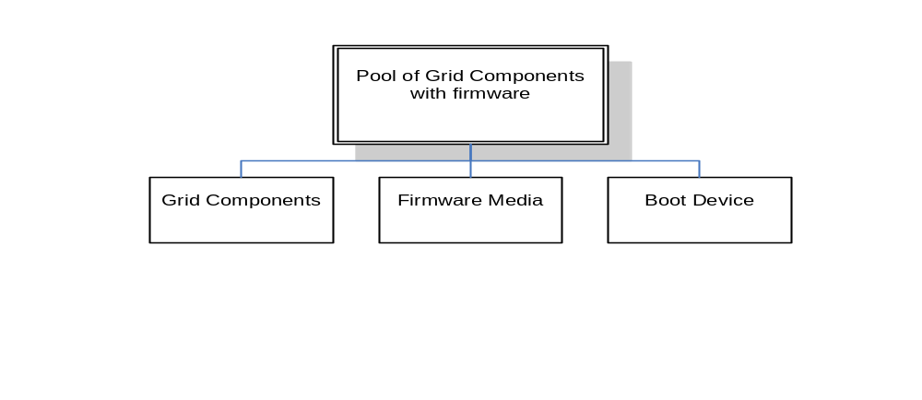
Figure 4 - Provision Firmware to Pool DAG

Basic Flow
Referring to Figure 1 – Provision firmware to Pool DAG above. For each grid component in the pool, refer to the flow described in the relevant use cases as described below.
- Follow the flow in use case Provision Firmware (section 3.3)
- Update Pool Configuration in GME
Update the pool configuration in the GME repository to reflect the new firmware running on each grid component in the pool

Alternative Flows
None

Exceptional Flows
In the event provisioning firmware to a grid component fails, the GME should respond by removing that grid component from the pool and adding a replacement component to the pool. The GME would then provision firmware to the replacement grid component. If no suitable replacement components are available, the operation should either fail, or succeed in a limited manner, depending on pool policies.

Success Criteria
The grid components in the pool are all running the required firmware versions. All components in the pool are activated. Service level metrics for the pool are met.

Post Conditions
The grid components in the pool are active and available for the GME to deploy services onto.

Decommission Firmware On Pool

Summary
This use case shows the process associated with the removal of firmware from a pool of target grid components. In reality, such a process rarely exists, as firmware is usually overwritten.

Dependencies
This use case builds upon the following use cases:
- Decommission Firmware: See section 3.4

Actor(s)/Stakeholder(s)
- Primary actor is GME
- Secondary actors which may act on behalf of the GME include:
  - Data Center Admin
  - Network Admin
  - Storage admin
  - System admin
  - Security Admin

Pre-Conditions
- The workload or service hosted by the pool has terminated
- There is no longer a reservation for this pool in the GME respository

Initiation Of Use Case
The GME detects that the reservation for this pool that assigned it to a service has been cancelled, and policy for this pool states that firmware should be removed from a grid component in the pool once it is no longer in use.

Flow Of Events
(Basic, Alternative And Exceptional)
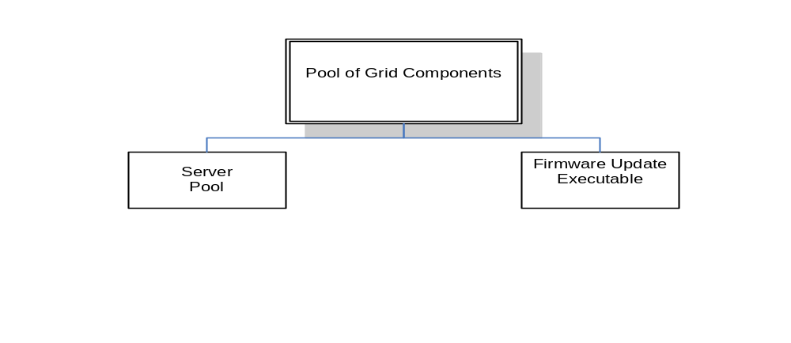
Figure 1 - Decommission Firmware from Pool DAG

Basic Flow
- Decommission firmware for each grid component in pool as described in use case 3.4
- Update Pool Configuration in GME
Update the pool configuration in the GME repository to reflect the OS is no longer running on any servers in the pool.

Alternative Flows
None

Exceptional Flows
GME will verify no services are active on any grid component. If a grid component is hosting an active service, the operation on that grid component will fail.

Success Criteria
All grid components in the pool have been shut down, and none are have any firmware.

Post Conditions
The grid components in the pool are ready to be provisioned with new firmware

Provision OS To Pool

Summary
Servers are added to a pool with the intent of running some workload within the pool. This will require the servers be booted with an operating system suitable for the workload to be supported. This use case describes the activity associated with booting the servers in the pool with an appropriate operating system (type, version, and patches).

Dependencies
This use case builds upon the following use cases:
- Use case 9.3, Provision an OS Instance to a Server

Actor(s)/Stakeholder(s)
- Primary Actor is the GME
- Secondary actors which may act on behalf of the GME include:
  - Data Center Admin
  - Network Admin
  - Storage admin
  - System admin
  - Security Admin

Pre-Conditions
- The various grid components, as enumerated in the DAG are manageable by the GME.
- All SLOs and constraints for the grid components have been defined.
- Use of the grid component and its intended deployment has been appropriately licensed or will be appropriately licensed in parallel to the provisioning process.
The use case also assumes the following pre-requisites:
- The pool has been created as described in Create a Pool of Components.
- Physical servers have been added to the pool as described in Add Physical Server to Pool Object.
- Administrative rights have been granted as described in Grant Admin Rights to Pool.

Initiation Of Use Case
The GME determines additional servers, and associated operating systems, are required to host a service inorder to meet SLOs.

Flow Of Events
(Basic, Alternative And Exceptional)

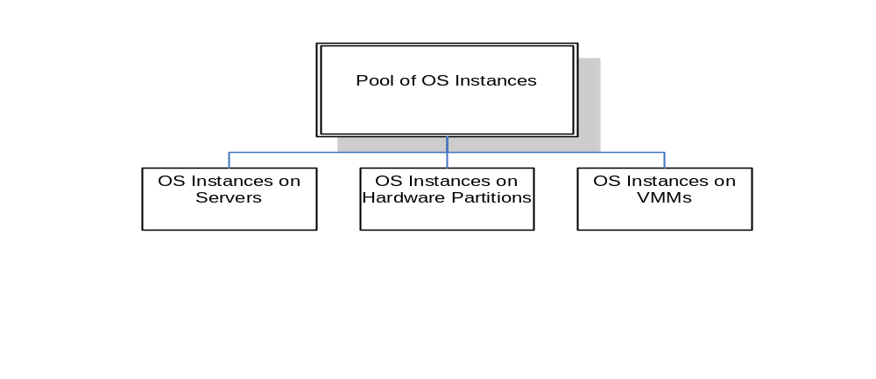
Figure 5 - Provision OS to Pool DAG

Basic Flow
Referring to Figure 6 – Provision OS to Pool DAG above. For each server in the pool, refer to the flow described in the relevant use cases as described below.
- Provision OS to each server in pool as described in use case 9.3
- Update Pool Configuration in GME
Update the pool configuration in the GME repository to reflect the OS is now running on additional servers in the pool.

Alternative Flows
Some servers in the pool may already be running the appropriate OS, and may only need to be restarted.

Exceptional Flows
In the event provisioning an OS to a server fails, or the server fails to meet metric objectives or generates other errors, the GME should respond by removing that server from the pool and adding a replacement server to the pool. The GME would then provision an OS to the replacement server. If no suitable replacement servers are available, the operation should either fail, or succeed in a limited manner, depending on pool policies.

Success Criteria
The servers in the pool are all running the required OS types, versions and patches. All servers in the pool are activated. Service level metrics for the pool are met.

Post Conditions
The serves in the pool are active and available for the GME to deploy services onto.

Decommission OS On Pool

Summary
This use case will decommission the operating system from a pool of servers that are no longer needed to host a service. This will prepare them for reuse by another service.

Dependencies
This use case builds upon the following use cases:
- Use case 9.5, Decommission OS Instance From Server:

Actor(s)/Stakeholder(s)
- Primary actor is GME
- Secondary actors which may act on behalf of the GME include:
  - Data Center Admin
  - Network Admin
  - Storage admin
  - System admin
  - Security Admin

Pre-Conditions
- The workload or service hosted by the pool has terminated
- There is no longer a reservation for this pool in the GME respository

Initiation Of Use Case
The GME detects that the reservation for this pool that assigned it to a service has been cancelled.

Flow Of Events
(Basic, Alternative And Exceptional)
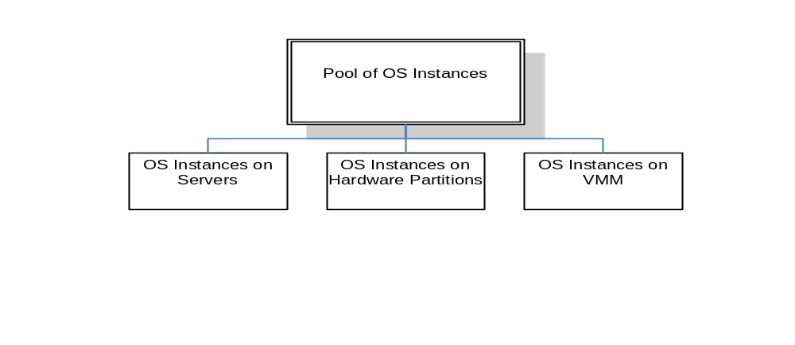
Figure - Decommision OS from Pool DAG

Basic Flow
- Decommission OS for each server in pool as described in Use case 9.5
- Update Pool Configuration in GME
Update the pool configuration in the GME repository to reflect the OS is no longer running on any servers in the pool.

Alternative Flows
Some servers in the pool may already have had their operating systems decommissioned and may be shut down.

Exceptional Flows
GME will verify no services are active on any server. If a server is hosting an active service, the operation on that server will fail.

Success Criteria
All servers in the pool have been shut down, and none are associated with an operating system

Post Conditions
The servers in the pool are ready to be provisioned to another operating system and service.

Set State Of Pooled Servers

Summary

This use case describes the process involved in Setting state of Pooled Servers.

Dependencies
None

Actor(s)/Stakeholder(s)
- System admin
- Network Admin
- Storage Admin
- Security Admin
- GME

Pre-Conditions
- The GME exists.
- The GME repository exists.
- The GME daemons exist on the device.
- Desired Pool is formed with proper resources.

Initiation Of Use Case
The required daemons are started/configured on the grid.

Flow Of Events
(Basic, Alternative And Exceptional)

Basic Flow
- Verify the Pool Definition and its current implementation.
- Make sure the Pool is operational.
- Formulate Pool State vector information consisting of states of the servers from the Pool.
- Update the Pool State Vector to the GME repository.
- Send a notification to the system admin.

Alternative Flows
Step 1: If the GME repository already has the correct Pool Servers State Information, then the corresponding steps may be skipped. If the Pool Configuration State Vector is being upgraded due to changes to the Pool Structure, this info is logged, and a message is sent to the system admin and GME.

Exceptional Flows
If any steps fail then they are repeated until successful, or a notification is sent to the system admin and GME, as specified by a policy engine.

Success Criteria
The Pool Servers State Information (which denotes the constituent servers and their states) has been added to the GME repository and a notification sent to the system admin.

Post Conditions
The Pool Servers State Information is available to the GME.

Get State Of Pooled Servers

Summary

This use case describes the process involved to Get State Of Pooled Servers.

Dependencies
None

Actor(s)/Stakeholder(s)
- Network Admin
- Storage Admin
- System admin
- Security Admin
- GME

Pre-Conditions
- The GME exists.
- The GME repository exists.
- The GME daemons exist on the device.
- Desired Pool is formed with proper resources.

Initiation Of Use Case
The required daemons are started/configured on the grid.

Flow Of Events
(Basic, Alternative And Exceptional)

Basic Flow
- Verify the Pool Definition and its current implementation.
- Make sure the Pool is operational.
- Present the Get State Of Pooled Servers Query to the GME.
- Obtain Pool Servers State Vector with State Vector Values.
- Send Pool Servers Vector Information to the requesting admin/s.

Alternative Flows
Step 1: If the Pool Servers State Vector is being upgraded due to changes to the Pool Structure, this info is logged, and a message is sent to the system admin/s and GME after the successful upgrade of the Pool Servers State Vector.

Exceptional Flows
If any steps fail then they are repeated until successful, or a notification is sent to the system admin and GME, as specified by a policy engine.

Success Criteria
The Pool Servers State information is obtained and sent to the requesting admin/s. Pool State vector consists of information related to Pool constituent servers and their states.

11.20.8 Post Conditions
The pool policy information is available to the requesting admins.

Provision Patch To Pool

Summary
This use case describes the process associated with the application of a patch to a Pool. Nothing is assumed about the starting state of the component or about the grid components.

Dependencies
- Use case 10.3, Provision patch

Actor(s)/Stakeholder(s)
- Network Admin
- Storage Admin
- System admin
- Security Admin
- GME

Pre-Conditions
- The GME exists.
- The GME repository exists.
- The patch media exists in the GME.
- The pool exists

Initiation Of Use Case
Provisioning of a patch to the Pool is requested. This may be for any reason, ranging from a notification from a software vendor to an in-house patch for some known problems.

Flow Of Events
(Basic, Alternative And Exceptional)

Basic Flow
- GME updates the information repository and makes the Pool to be decommissioned as unavailable during the decommissioning process.
- GME stops any running applications, and updates repository. (This may be another use case.)
- GME starts the specified Pool with the right privilege level, if needed.
- GME updates information repository about dependencies, relevant reasons etc.
- For each server in the pool, follow the steps of use case 10.3, provision patch.
- GME checks the log files for correct provisioning.
- GME repeats steps 5) - 6) if the decommissioning was not successful as specified by a policy engine.
- GME updates its repository.
- GME makes Pool available for use.
- GME sends a notification to the subscribed users about the provisioned patch.
- GME restarts applications on the patched Pool.

Alternative Flows

Exceptional Flows
If any steps fail then they are repeated for a specified number of times until successful, or a notification is sent to the system admin, as specified by a policy engine.

Success Criteria
The new patch has been installed on the specified Pool in the grid, and relevant info added into the repository of the GME, and a notification sent to the subscribed stakeholders.

Post Conditions
The new patch has been installed on the specified Pool in the grid, and relevant info added into the repository of the GME.

Decommission Patch From Pool

Summary
This use case describes the process by which a patch is rolled back. This is usually done through rolling back to a backed up version of the OS.

Dependencies

- Use case 10.4, Decommission patch

Actor(s)/Stakeholder(s)
- Network Admin
- Storage Admin
- System admin
- Security Admin
- GME

Pre-Conditions
- The GME exists.
- The GME repository exists.
- The patch exists on the Pool.
- The pool exists

Initiation Of Use Case

Decommissioning of a patch is requested. This may be for any reason, e.g., software compatibility of an existing application.

Flow Of Events
(Basic, Alternative And Exceptional)

Basic Flow
- GME updates the information repository and makes the Pool to be decommissioned as unavailable during the decommissioning process.
- GME stops any running applications, and updates repository. (This may be another use case.)
- GME starts the specified Pool with the right privilege level, if needed.
- GME updates information repository about dependencies, relevant reasons etc.
- For each server in the pool, follow the steps in use case 10.4, Decommission patch.
- GME checks the log files for correct decommissioning.
- GME repeats steps 5-6 if the decommissioning was not successful as specified by a policy engine.
- GME updates its repository.
- GME makes decommissioned Pool available for use.
- GME sends a notification to the subscribed users about the decommissioned patch.
- GME restarts applications on the patched Pool.

Alternative Flows
Try a manual decommission of the patch.

Exceptional Flows
If any steps fail then they are repeated for a specified number of times until successful, or a notification is sent to the system admin, as specified by a policy engine.

Success Criteria
The patch has been decommissioned on the specified Pool in the grid, and relevant info added into the repository of the GME, and a notification sent to the subscribed stakeholders.

Post Conditions
The patch has been decommissioned on the specified node in the grid, and relevant info added into the repository of the GME.

Provision VMM To Pool

Summary
This use case describes the process involved to provision Virtual Machine Monitor software to Pool.

Dependencies
This use case depends upon the following use cases –
- 7.43 Create Pool Of Components
- 7.46 Add Physical Server To Pool Object
- 7.48 Add Virtual resources To Pool Object
- 7.54 Get Pool Configuration
- 5.01 Provision VMM Media to GME.

Actor(s)/Stakeholder(s)
- Installation Engineer
- Server Admin
- Network Admin
- Storage Admin
- Server Admin
- Security Admin
- GME

Pre-Conditions
- The GME exists.
- The GME repository exists.
- The GME daemons exist on the device.
- Desired Pool is formed with proper resources.

Initiation Of Use Case
The required daemons are started/configured on the grid.

Flow Of Events
(Basic, Alternative And Exceptional)

Basic Flow
- Verify the Pool Definition and its current implementation.
- Make sure the Pool is operational.
- Apply VMM Media to Physical Servers which are constituents of the Pool.
- Verify the completion of the VMM Media Application.
- Update GME with new Pool State Vector.

Alternative Flows
Step 1: Physical Servers are applied the VMM Media. The use case obtains the Virutal Pool constituents and makes sure that the members have the VMM media and updates the Pool State vector definition in the GME repository.

Exceptional Flows
If any steps fail then they are repeated until successful, or a notification is sent to the system admin and GME, as specified by a policy engine.

Success Criteria
Pool has VMM media.

Post Conditions
The Pool can start hosting virtual homogeneous/heterogeneous application environments.

Decommission VMM from Pool

Summary
This use case describes the process involved in decomissioning Virtual Machine Monitors from a Pool.

Dependencies
This use case depends upon the following use cases –
- 7.43 Create Pool Of Components
- 7.46 Add Physical Server To Pool Object
- 7.48 Add Virtual resources To Pool Object
- 7.50 Grant Admin Rights To Pool
- 7.54 Set Pool Configuration
- 7.55 Provision VMM To Pool

Actor(s)/Stakeholder(s)
- Installation Engineer
- Server Admin
- Network Admin
- Storage Admin
- Server Admin
- Security Admin
- GME

Pre-Conditions
- The GME exists.
- The GME repository exists.
- The GME daemons exist on the device.
- Desired Pool is formed with proper resources.

Initiation Of Use Case
The required daemons are started/configured on the grid.

Flow Of Events
(Basic, Alternative And Exceptional)

Basic Flow
- Verify the Pool Definition and its current implementation.
- Make sure the Pool is operational.
- Remove VMM Media from Physical Servers which are constituents of the Pool.
- Verify the completion of the VMM Media Removal Process.
- Update GME with new Pool State Vector.

Alternative Flows
Step 1: VMM Media is removed from the Physical Servers. The use case obtains the Virutal Pool constituents and makes sure that the members have the VMM media removed and updates the Pool State vector definition in the GME repository.

Exceptional Flows
If any steps fail then they are repeated until successful, or a notification is sent to the system admin and GME, as specified by a policy engine.

Success Criteria
Pool has VMM media decommissioned.

Post Conditions
The Pool can no more host virtual homogeneous/heterogeneous application environments.

Provisioning Databases
This chapter will describe the use cases associated with provisioning and decommissioning databases. A database service is a grid component that is built upon several other grid components. The use cases in this chapter will describe the provisioning of the database service, and the dependent database files and database instance grid components. The DAG for these use cases is shown below in figure 13.1.
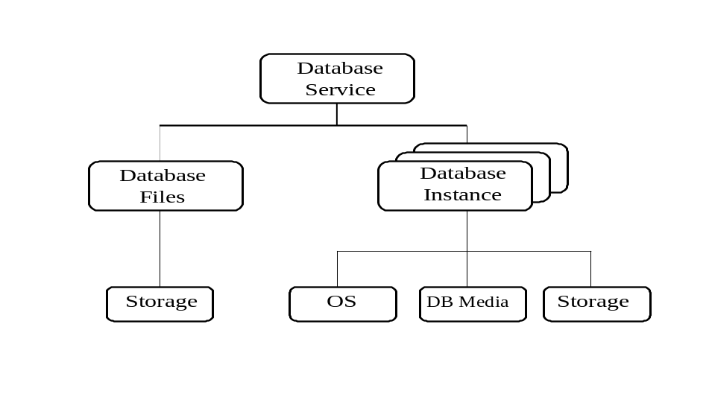
Figure 13.1: Database Provisioning DAG

Provision Database Data Files

Summary
Provision the physical database data files that will host the data. The data files represent the database. The database and data files already exist and likely contains data, or will be created as an empty database.

Dependencies
Dependent use cases will depend upon what type of storage will host the database files. This could include a file system (regular, network, or clustered), raw volumes, or database managed such as Oracle ASM. Depending on the type of storage used, one of the following use cases will be a dependency.
- Provision File System: Use case #TBD
- Provision Database Managed Storage: Use case #TBD

Actor(s)/Stakeholder(s)
- Data Center System Admin
- Data Center Network Admin
- Data Center Storage Admin
- Data Center Server Admin
- Data Center Security Admin
- Data Center Database Admin
- GME

Pre-Conditions
- If the database data files exist, they are known to the GME.
- Existing database files are available on storage that can be made accessible to the GME and to the server where the service (instance) will be started.
- If a new set of data files (database) is to be created, storage is available to create the data files.
- If a new set of data files (database) is to be created, the database creation utility is available to the GME and the server that will run the utility.
- The server that will host the instance that will mount the database has been identified and is controllable via the GME.
- Service level objectives are known for all services that will provide access to these files, or information that will indicate the minimum number of spindles across which the files should be stipped.

Initiation Of Use Case
The GME determines that the database data files must be activated and made available to other services in the grid.

Flow Of Events
(Basic, Alternative And Exceptional)

Basic Flow
For simplicity, the basic flow assumes the data files already exist. It also assumes the files already are stored in a location suitable for an active database. See the alternative flow for the case where the data files do not exist, or where they must be relocated before they can be activated.
1. Create Database
The database should already exist in the GME repository.
2. Configure the database data files
- Identify the physical database data files that will serve as a container for the data to be provided by the database service. Verify they are located in storage capable of supporting service levels desired for an active database.
- Identify the server that will host the database.
- From the server that will host the database, mount the storage location containing the data files, or copy/move the data files to a location accessible to the server.
3. Activate database data files
Mark the database files as active in the GME repository

Alternative Flows
If the database data files do not already exist, or are stored in a location unable to meet service levels, follow an alternative flow.
Alternative Flow 1: Data files do not exist.
- Create database files
Register the database files with the GME
- Configure database
Provision storage suitable for hosting database files. Files can be hosted on a file system, or on database managed storage.
- Files system: Provision file system as described in use case #xxx, “Provision a file system”
- Database Managed Storage: Provision database managed storage as described in use case #xxx, “Provision Database Managed Storage”.
Run the database creation tool to create a new set of data files.
- Activate database files
Register the database files as active in the GME
Alternative Flow 2: Files must be relocated to meet service level objectives.
- Create database files
The data files should already exist within the GME
- Configure database
Provision storage suitable for hosting database files. Files can be hosted on a file system, or on database managed storage.
- Files system: Provision file system as described in use case #xxx, “Provision a file system”
- Database Managed Storage: Provision database managed storage as described in use case #xxx, “Provision Database Managed Storage”.
Mount the location containing the data files and copy to the new location.
- Activate database files
Register the database files as active in the GME

Exceptional Flows
If any steps fail then they are retried. After successive failures an exception is declared and the environment is flagged for follow-up by a database administrator.

Success Criteria
The database data files are accessible to processes running on the server.

Post Conditions
The database data files are active and available for an instance to mount.

Decommission Database Data Files

Summary
Decommsion the physical database data files that will host the data. The data files represent the database. The database data files will most likely not be destroyed but will be saved in an inactive state for future provisioning. The files may be moved to an archival location, or left in place.

Dependencies

Actor(s)/Stakeholder(s)
- Data Center System Admin
- Data Center Network Admin
- Data Center Storage Admin
- Data Center Server Admin
- Data Center Security Admin
- Data Center Database Admin
- GME

Pre-Conditions
- All instances that had mounted the database data files have been decommissioned.
- If the files will be archived to other storage, that storage is accessible to the GME the server that has currently mounted the database files

Initiation Of Use Case
The GME determines that the database data files no longer need to be available for mounting by a database instance and can be archived for future use.

Flow Of Events
(Basic, Alternative And Exceptional)

Basic Flow
1. Stop Database Files
Mark the files as unconfigured in the GME repository
2. Unconfigure the database data files
- For any server that had mounted the database files, unmount the storage location hosting the files
3. Destroy database data files
This step is seldom performed.
- Delete the data files from storage
- Mark the datafiles as destroyed in the GME.

Alternative Flows
If the database data files are moved to archival or other storage, the archive location will be mounted and the GME will instruct the server to copy the files to the archival location. The files will then be deleted from their prior location.

Exceptional Flows
If any steps fail then they are retried. After successive failures an exception is declared and the environment is flagged for follow-up by a database administrator.

Success Criteria
The database data files no longer available to the server.

Post Conditions
The database data files are inactive and available for an for future provisioning. In rare circumstances, the data files will have been destroyed and no longer available for provisioning.

Provision A Database Instance

Summary
Provision a database instance to host a database service. The instance will mount a physical database (set of database data files) and provide access to the data in the data files.

Dependencies
- Use Case xxx: Provision storage
- Use Case 10.1: Provision OS Instance
- Use Case 3.1: Provision Generic Media

Actor(s)/Stakeholder(s)
- Data Center System Admin
- Data Center Network Admin
- Data Center Storage Admin
- Data Center Server Admin
- Data Center Security Admin
- Data Center Database Admin
- GME

Pre-Conditions
- All required software licenses are available, and software binaries are available on the grid.

Initiation Of Use Case
The GME determines that the database engine must be activated and made available to other services in the grid.

Flow Of Events
(Basic, Alternative And Exceptional)

Basic Flow
The basic flow assumes we will install the database binary files using an installation master image, most likely copied from a database installation media. The alternative flow describes installing the database binary files using an pre-installed and semi-configured master image of the database binaries
Provision dependent Grid components as described in the DAG in figure 13.1:
- Provision an operating system image on a server to host the database instance, as described in use case 10.1
- If necessary, provision the database installation media using the generic procedures described in use case 3.1.
- Provision local or remote storage to host the database binary, configuration, log, trace, and archive files.
Once all dependent grid components are provisioned, provision the database instance:
- Validate the environment and test for sufficient memory, swap space, tmp space, OS version, cpu type, software packages, etc.
- Create required users and groups if they do not already exist. For Oracle installations, for example, you normally create an “oracle” user and a “dba” group.
- On a Unix of Linux system, persistently set the required kernel parameters (for example, semmsl, semmns, semopm, semmni, shmall) and other parameters.
- Create required directories in which to install or copy the software. Set appropriate permissions and owners.
- Set environment variables for the user who will install and manage the database software.
- Mount the location containing the database installation files.
- Configure the response file for the installation program. Since this will be an unattended install, a response file is used to configure the installation program.
- Run the installation program and supply the response file
- Configure the networking (listener) files
- Start the listener
- Start the instance
- If necessary, configure the database instance by setting initialization and other parameters. In some cases, it may be necessary to restart the database after configuration.
- Parse installation log and verify successful installation.
- Verify connectivity to the database.

Alternative Flows
Lines 6-8: In some circumstances, the database may be installed by copying a pre-installed image (for example, an Oracle home) to the local disks, rather than running an installation program.

Exceptional Flows
If any steps fail then they are retried. After successive failures an exception is declared and the environment is flagged for follow-up by a database administrator.

Success Criteria
A test application can connect to and query the database.

Post Conditions
The database instance is active and available for the GME to deploy other grid components or services onto.

Decommission a Database Instance

Summary
Decommission a database instance.

Dependencies
- Use Case 10.3: Decommission OS Instance
- Use Case xxx: Decommission storage

Actor(s)/Stakeholder(s)
- Data Center System Admin
- Data Center Network Admin
- Data Center Storage Admin
- Data Center Server Admin
- Data Center Security Admin
- Data Center Database Admin
- GME

Pre-Conditions
- Database services provided by the instance have been decommissioned.

Initiation Of Use Case
The GME determines that the database instance must be decommissioned

Flow Of Events
(Basic, Alternative And Exceptional)

Basic Flow
- Shutdown the instance. Normal shutdown will wait for any users to disconnect, and will dismount the data files.
- Optionally backup the database and log files
- Shutdown the listener (if desired).
- Shutdown any management agents or daemons no longer required
- Run the installation program to deinstall the database software, or optionally delete the database binaries and supporting files.
- Delete database log files
Decommission any dependent grid components:
- If no other services are dependent on the OS image, decommission the OS instance as described in use case 10.3
- If the storage hosting the database binary, log, configuration, archive files is no longer needed, decommission the storage as described in use case xxx.

Alternative Flows

Exceptional Flows
If any steps fail then they are retried. After successive failures an exception is declared and the environment is flagged for follow-up by a database administrator.

Success Criteria
The database binaries have been removed.

Post Conditions
The server that previously hosted the database image is available for other workloads.

Provision A Database Service

Summary
Provision a database service to the enterprise grid so that it is accessible to other services, and manageable via the GME. For the purposes of this document, a database service is defined as access to a named database at a defined service level. Thus a single database could be accessible by more than one service. Note the service does not define access privileges, as those are defined by the username with which a user logs in.
The underlying grid components may or may not already be provisioned. They may also be shared with other database services. It is assumed the GME will be orchestrate the grid components to create, configure, and start the service.
This is a simple single-instance database service.

Dependencies
- Use Case 13.1: Provision database files
- Use Case 13.3: Provision an instance

Actor(s)/Stakeholder(s)
- Data Center System Admin
- Data Center Network Admin
- Data Center Storage Admin
- Data Center Server Admin
- Data Center Security Admin
- Data Center Database Admin
- GME

Pre-Conditions
- The database service is defined and known to the GME
- The required database files are available on storage that can be made accessible to the GME and to the server where the service will be hosted
- A DAG for the database service exists and identifies pre-requisite grid components and dependencies
- An SLO for the service exists, and grid component capacity information is available to derive component-level SLOs for the pre-requisite grid components.
.

Initiation Of Use Case
The GME determines that the database service must be activated and made available to other services in the grid.

Flow Of Events
(Basic, Alternative And Exceptional)

Basic Flow
For simplicity, the basic flow does not detail the provisioning of the lower level grid components.
1. Identify Pre-requisite Components
The GME uses a DAG for the database service to identify any pre-requisite grid components required by the database service. Based upon the DAG, it determines the following pre-requisite components are required.
- Database instance (GME database agents, database instance, listener)
- Database data files
2. Provision Pre-Requisite Components
- Provision database data files (see use case 13.1)
- Provision database instance (see use case 13.3)
3. Create Database Service
In most cases, the database service will already exist and be known to the GME. In some circumstances, however, the GME will require a new database service. This service can be incrementally associated to an existing database, or a new database. Service will be entered in GME repository.
Configure Database Service
Configure the database engine (instance) to provide the service.
Start Database Service
Enable the service on the database engine.

Alternative Flows
Lines 2a, 2b: If suitable pre-requisite grid components already exist, some or all of these steps may be skipped. For example, an existing set of database instances may be able to host the database service, without need for additional capacity.

Exceptional Flows
If any steps fail then they are retried. After successive failures an exception is declared and the environment is flagged for follow-up by a database administrator.
.

Success Criteria
The database service is available to other services, and meeting it’s derived SLOs

Post Conditions
The database service is active and available for the GME to deploy other grid components or services onto.

Decommission a Database Service

Summary
Decommission a database service.

Dependencies
- Use Case 13.2: Decommission database files
- Use Case 13.4: Decommission instance

Actor(s)/Stakeholder(s)
- Data Center System Admin
- Data Center Network Admin
- Data Center Storage Admin
- Data Center Server Admin
- Data Center Security Admin
- Data Center Database Admin
- GME

Pre-Conditions
- The database service is active
- No active applications or other grid components are dependent on this service
.

Initiation Of Use Case
The GME determines that the database service is no longer required

Flow Of Events
(Basic, Alternative And Exceptional)

Basic Flow
Stop Database Service
- The database service is marked inactive in the GME repository
- The database service is disabled. The database instance should automatically notify the listeners to no longer forward requests for the service
Unconfigure Database Service
- The database instance is persistently altered to no longer provide the service.
- The database service is marked unconfigured in the GME repository
- If this is the last service supported by the database instances, optionally deprovision the database instances as described in Use Case 13.4
- If all instances have been deprovisioned, optionally deprovision the database data files as described in Use Case 13.2.
Destroy Database Service
The database service is marked destroyed in the GME repository.

Alternative Flows

Exceptional Flows
If any steps fail then they are retried. After successive failures an exception is declared and the environment is flagged for follow-up by a database administrator.
.

Success Criteria
The database service is no longer available to other services.

Post Conditions
Requests to the database services are returned by the listener with an error.

Provisioning Application Servers

These use cases deal with provisioning/deprovisioning of an application server, and an application service in a data center in order to meet the SLOs and/or constraints of a service or business application. The steps shown are specific to a JBoss instance, but similar process can be followed for other types of application servers. The information exchange between various entities in the data center is by means of documents (e.g., XML documents). This version of the use case does not cover virtual machines. This step would be added later.

DAG

Provision management Software agent(s)
Provision application server media
Create Application Server instance
Start Application Server instance
Provision Logical Server
Provision OS Media
Provision Boot Disk/LUN
Create and Configure, and Start OS instance
Start
End

Provision An Application Server Instance

Summary
This use case deals with provisioning an application server in a data center in order to meet the SLOs and/or constraints of a service or business application. The steps shown are specific to a JBoss instance, but similar process can be followed for other types of application servers. The information exchange between various entities in the data center is by means of documents (e.g., XML documents). This version of the use case does not cover virtual machines. This step would be added later.

Dependencies
This use case is dependent on, i.e. it invokes the following use cases, if needed. The use case traverses a DAG (directed acyclic graph), and checks whether the required software has been already installed in which case it skips the corresponding use case, otherwise, it invokes the intervening use cases before moving on to the next level use case in the DAG.

- Provision Logical Server
- Provision OS media
- Provision Boot Disk/LUN – Local Disk
- Provision Boot Disk/LUN – SAN
- Provision Boot Disk/LUN – NAS
- Provision OS instance
- Provision management software agent(s) media
- Provision management software agent(s)
- Provision application server media

Pre-Conditions
The server is manageable by the management software; media for OS, application server and other needed software exists in the datacenter repository; software licensing mechanisms exist; SLOs and constraints for this use case have been defined.

Actor(s)/Stakeholder(s)
- Primary actor is the management software
- Secondary actors which may act on behalf of the management software include:
  - System Admin
  - Server Admin
  - Application Admin
  - GME

Initiation Of Use Case
The management software determines an additional application server, and associated logical server, storage, and operating system, is required to host a service in order to meet SLOs.

Flow Of Events
(Basic, Alternative And Exceptional)

Basic Flow
In order to provision an active application server instance, the DAG must be traversed as mentioned above. Here are the steps:
- An actor submits a request for provisioning an application server to the management software. The various attributes/properties are either input from a user interface, or provided in an XML file.
- From the provided information, the system generates an XML file which is used by the various use cases below.
- Check whether the dependent use cases have been executed. If not, execute the dependent use cases as listed under Dependencies section before moving to the next steps.
- Create Application Server instance Component
The management software issues a command to request creation of an instance of an application server on the logical server. The attributes like CPU type, OS, Memory, Disk, Network, Application Server type etc, are specified in an XML file.
The following are the main steps in installing the application server:
-check that the various attributes of the logical server are compatible with the application server type
-check whether the system is running with the correct privilege levels, otherwise, switch to a correct privilege level, or stop other processes, and reboot the system with the correct privilege level
-check whether the system has the pre-requisites for running the application server. These include the specified JDK version, ant etc. If not, follow the use cases for installing JDK, and ant before going to the next step
-download the specified version of the tar/zip archive file for the application server from the central repository into a specified directory
-uncompress/unarchive the archive file in the specified directory
-configure various environment variable like JBOSS_Home, and Path on the system
-run the start script to launch the application server
-send a notification to the system admin to test that the application server is running properly, by accessing the JMX console from a remote system. Alternatively, use a custom client application to do a handshake with the application server on the server’s listener port.
- Log the information in the system log files.
- Notify the user/subscribers of the successful completion of the use case.

Alternative Flows
Many other flows are possible depending on the type of application servers, and the operating systems.

Exceptional Flows
Exceptions would be generated if the appropriate software components are not available, or any of the steps generate errors.

Success Criteria
The specified application server instance is installed and activated.

Post Conditions
The application server instance is active and available for the management software to deploy other software components or services onto.

Decommissioning an Application Server Instance

Summary
This use case deals with de-provisioning an application server in a data center in order to meet the SLOs and/or constraints of a service or business application. The steps shown are specific to a JBoss instance, but similar process can be followed for other types of application servers. The information exchange between various entities in the data center is by means of documents (e.g., XML documents). This version of the use case does not cover virtual machines. This step would be added later.

Dependencies
There are no dependencies for this use case.

Pre-Conditions
The server is manageable by the management software; media for OS, application server and other needed software have been deployed previously; software licensing mechanisms exist; SLOs and constraints for this use case have been defined.

Actor(s)/Stakeholder(s)
- Primary actor is the management software
- Secondary actors which may act on behalf of the management software include:
  - System Admin
  - Server Admin
  - Application Admin
  - GME

Initiation Of Use Case
The management software determines a specified application server instance needs to be decommissioned.

Flow Of Events
(Basic, Alternative And Exceptional)

Basic Flow
In order to decommission an active application server instance, the following steps need to be followed:
- An actor submits a request for decommissioning an application server to the management software. The various attributes/properties are either input from a user interface, or provided in an XML file.
- From the provided information, the system generates an XML file which is used by the various steps below.
- Decommission Application Server instance Component
The management software issues a command to request decommissioning of an instance of an application server on the logical server. The attributes like CPU type, OS, Memory, Disk, Network, Application Server type etc, are specified in an XML file.
The following are the main steps in decommissioning the application server:
-check whether the system is running with the correct privilege levels, otherwise, switch to a correct privilege level, or stop other processes, and reboot the system with the correct privilege level
-query the management software agent(s) running on the server for applications deployed within the application server. Invoke the notification service to notify users registered with these applications about the impending stoppage of the service. Run the scripts to stop these applications, delete the binaries, configuration and other files related to this application server instance. Update the information repository, and log files accordingly.
-unconfigure various environment variable like JBOSS_Home, and Path on the system
-send a notification to the system admin to test that the application server is decommissioned properly by accessing the JMX console from a remote system. Alternatively, use a custom client application to do a handshake with the application server on the server’s listener port.
- Log the information in the system log files.
- Notify the users/subscribers of the successful completion of the use case.

Alternative Flows
Many other flows are possible. For example, the decommissioning may have to wait for a certain amount of time as the application server may be is use.

Exceptional Flows
Exceptions would be generated if the appropriate software components are not available, or any of the steps generate errors.

Success Criteria
The specified application server instance is decommissioned.

Post Conditions
The application server instance is decommissioned and the node is available for the management software to deploy other software components or services onto.

Provision An Application Service

Summary
This use case deals with provisioning an application service in a data center in order to meet the SLOs and/or constraints of a service or business application. The steps shown are specific to a JBoss application server, but similar process can be followed for other types of application servers. The information exchange between various entities in the data center is by means of documents (e.g., XML documents). This version of the use case does not cover virtual machines. This step would be added later.

Dependencies
This use case is dependent on, i.e. it invokes the following use cases, if needed. The use case traverses a DAG (directed acyclic graph), and checks whether the required software has been already installed in which case it skips the corresponding use case, otherwise, it invokes the intervening use cases before moving on to the next level use case in the DAG.

- Provision Logical Server
- Provision OS media
- Provision Boot Disk/LUN – Local Disk
- Provision Boot Disk/LUN – SAN
- Provision Boot Disk/LUN – NAS
- Provision OS instance
- Provision management software agent(s) media
- Provision management software agent(s)
- Provision application server media
- Provision application server

Pre-Conditions
The server is manageable by the management software; media for OS, application service and other needed software exists in the datacenter repository; software licensing mechanisms exist; SLOs and constraints for this use case have been defined.

Actor(s)/Stakeholder(s)
- Primary actor is the management software
- Secondary actors which may act on behalf of the management software include:
  - System Admin
  - Server Admin
  - Application Admin
  - GME

Initiation Of Use Case
The management software determines an additional application service, and associated logical server, storage, and operating system, is required to host a service in order to meet SLOs.

Flow Of Events
(Basic, Alternative And Exceptional)

Basic Flow
In order to provision an active application service, the DAG must be traversed as mentioned above. Here are the steps:
- An actor submits a request for provisioning an application service to the management software. The various attributes/properties are either input from a user interface, or provided in an XML file.
- From the provided information, the system generates an XML file which is used by the various use cases below.
- Check whether the dependent use cases have been executed. If not, execute the dependent use cases as listed under Dependencies section before moving to the next steps.
- Create Application Service
In most cases, the application service will already exist and be known to the GME. In some circumstances, however, the GME will require a new application service. This service can be incrementally associated to an existing application, or a new application. service will be entered in GME repository.
- Configure Application Service
Download the binary files into the appropriate folders on the host node, configure the application descriptor files, and the application server to provide the service.
- Start Application Service
Restart the application server if need be to enable the service in the application server.
- Log the information in the system log files.
- Notify the user/subscribers of the successful completion of the use case.

Alternative Flows
Many other flows are possible. For example, configuration steps may vary for different application services, as well as different application server containers.

Exceptional Flows
Exceptions would be generated if the appropriate software components are not available, or any of the steps generate errors.

Success Criteria
The specified application service is installed and activated.

Post Conditions
The application service is active and available.

Decommission an Application Service

Summary
Decommission an application service running in an application server.

Dependencies

Actor(s)/Stakeholder(s)
- System Admin
- Server Admin
- Application Admin
- GME

Pre-Conditions
- The application service is active
- No active applications or other grid components are dependent on this service
.

Initiation Of Use Case
The GME determines that the application service is no longer required

Flow Of Events
(Basic, Alternative And Exceptional)

Basic Flow
Stop Application Service
- The application service is marked inactive in the GME repository
- The management agents notify the listeners that the service is going down. The application service is disabled.
Unconfigure Application Service
- The application service is persistently altered to no longer provide the service.
- The application service is marked unconfigured in the GME repository
Destroy Application Service
The application service is marked destroyed in the GME repository.

Alternative Flows

Exceptional Flows
If any steps fail then they are retried. After successive failures an exception is declared and the environment is flagged for follow-up by a application administrator. .

Success Criteria
The application service is no longer available to other services.

Post Conditions
Requests to the application service are returned by the application server with an error.

Future Use Cases
Some of the topics planned for future versions of this document include:
- Additional sections of Chapter 11 (Provisioning Pools of Servers)
  - Add Virtual Server to Pool Object
  - Remove Virtual Server from Pool Object
- Provisioning Operating System Level Clustering
- Provisioning Databases
- Provisioning Application Servers
- Provisioning Web Servers
- Provisioning Load Balancers
- Provisioning Firewalls
- Provisioning Database Clusters
- Provisioning Application Server Clusters
- Provisioning Database Server Tiers
- Provisioning Web Server Tiers
- Provisioning A Multi-Tier Service

